

OpenL Tablets WebStudio User Guide

^{OpenL Tablets 5.13}
OpenL Tablets BRMS

Document number: TP_EPB_7.1.0_OpenLWS_User_2.3_LShSN
Revised: 09-22-2014
OpenL Tablets Documentation is licensed under a Creative Commons Attribution 3.0 United States License.

Table of Contents
1 Preface 6
1.1 Audience 6
1.2 Related Information 6
1.3 Typographic Conventions 6
2 Introducing OpenL Tablets WebStudio 8
2.1 What Is OpenL Tablets WebStudio? 8
2.2 Working with Projects in OpenL Tablets WebStudio 8
2.3 OpenL Tablets WebStudio Components 9
2.4 Security Overview 10
3 Getting Started 11
3.1 Signing In to OpenL Tablets WebStudio 11
3.2 Modifying User Details 12
3.3 Modifying User Settings 12
3.4 Displaying the OpenL Tablets WebStudio Help 13
3.5 Signing Out of OpenL Tablets WebStudio 13
3.6 Introducing Rules Editor 14
Rules Editor Overview 14
View Modes 16
3.7 Introducing Repository Editor 19
4 Using Rules Editor 21
4.1 Filtering Projects 21
4.2 Viewing a Project 22
4.3 Viewing a Module 22
4.4 Managing Projects and Modules 23
Editing and Saving a Project 24
Updating and Exporting a Project 24
Exporting, Updating, and Editing a Module 25
Reverting Module Changes 27
4.5 Defining Project Dependencies 30
4.6 Viewing Tables 31
4.7 Modifying Tables 32
4.8 Managing Range Data Types 34
4.9 Creating Tables by Copying 38
Copying the Existing Table 38
Creating a New Version of the Table 39
Creating a Table as a New Business Dimension Version 39
4.10 Performing a Search 40
Performing a Simple Search 40
Performing an Advanced Search 41
4.11 Creating Tables 43
Creating a Datatype Table 43
Creating a Data Table 45
Creating a Simple Rules Table 47
5 Editing and Testing Functionality 51
5.1 Editing Tables 51
Editing a Comma Separated Array of Values 51
Editing Default Table Properties 51
Editing Inherited Table Properties 52
5.2 Using Table Versioning 56
5.3 Performing Unit Tests 58
Adding Navigation to a Table 58
Running Unit Tests 59
Creating a Test 65
5.4 Tracing Rules 66
5.5 Using Benchmarking Tools 69
6 Using Repository Editor 72
6.1 Browsing Design Repository 72
6.2 Filtering the Project Tree 73
6.3 Creating Projects in Design Repository 74
Creating a Project from Template 74
Creating a Project from Excel Files 75
Creating a Project from ZIP Archive 77
Importing a Project from Workspace 78
Creating a Custom Project Template 78
6.4 Opening a Project 79
6.5 Closing a Project 80
6.6 Editing a Project 80
6.7 Saving a Project 80
6.8 Modifying a Project 81
Modifying Project Properties 81
Modifying Project Contents 84
6.9 Copying a Project 87
6.10 Removing a Project 87
Deleting a Project 88
Erasing a Project 88
6.11 Deploying Projects 88
Creating a Deploy Configuration 89
Defining Projects to Deploy 89
Deploying a Deploy Configuration 90
Opening Deployed Configurations 90
Redeploying Projects 90
6.12 Comparing Project Revisions 91
6.13 Exporting a Project or a File 92
6.14 Unlocking a Project 93
6.15 Browsing Production Repository 93
7 Using Administration Tools 95
7.1 Managing System Settings 95
7.2 Common Settings 96
User Workspace 97
History 97
Other 97
7.3 Repository Settings 97
7.4 System Settings 99
Core 99
Project 99
Testing 99
7.5 User Management 99
Managing Groups 100
Managing Users 103
8 Index 107

Preface
This preface is an introduction to the OpenL Tablets WebStudio User Guide. The following topics are included in this preface:
- Audience
- Related Information
- Typographic Conventions

Audience
This guide is intended for the following users:
Audience
User type | Purpose | Required knowledge
Business users | View and modify company business rules stored in tables. | Knowledge of decision tables is required.
Developers | - Manage technical details of rule tables.  - Organize and deploy rule projects. | Knowledge of OpenL Tablets technology is required.

Related Information
OpenL Tablets WebStudio is a tool of the OpenL Tablets product. For information on OpenL Tablets Rules, see [OpenL Tablets Reference Guide].

Typographic Conventions
The following styles and conventions are used in this guide:
Typographic styles and conventions
Convention | Description
Bold | - Represents user interface items such as check boxes, command buttons, dialog boxes, drop-down list values, field names, menu commands, menus, option buttons, perspectives, tabs, tooltip labels, tree elements, views, and windows.  - Represents keys, such as F9 or CTRL+A.  - Represents a term the first time it is defined.
Courier | Represents file and directory names, code, system messages, and command-line commands.
Courier Bold | Represents emphasized text in code.
Select File > Save As | Represents a command to perform, such as opening the File menu and selecting Save As.
Italic | - Represents any information to be entered in a field.  - Represents documentation titles.
< > | Represents placeholder values to be substituted with user specific values.
Hyperlink | Represents a hyperlink. Clicking a hyperlink displays the information topic or external source.
[name of guide] | Reference to another guide that contains additional information on a specific feature.

Introducing OpenL Tablets WebStudio
OpenL Tablets WebStudioThis section introduces main OpenL Tablets WebStudio concepts. The following topics are included in this section:
- What Is OpenL Tablets WebStudio?
- Working with Projects in OpenL Tablets WebStudio
- OpenL Tablets WebStudio Components
- Security Overview

What Is OpenL Tablets WebStudio?
OpenL Tablets WebStudioOpenL Tablets WebStudio (further also referred as WebStudio) is a web application employed by business users and developers to view, edit, and manage business rules and rule projects created using OpenL Tablets technology. For more information on OpenL Tablets, see [OpenL Tablets Reference Guide].
By using OpenL Tablets WebStudio, users can modify rules directly in a web browser without installing additional tools. OpenL Tablets WebStudio provides an advanced functionality for creating and modifying rules, viewing errors, and executing tests.

Working with Projects in OpenL Tablets WebStudio
OpenL Tablets WebStudioOpenL Tablets WebStudio is intended for a multi-user environment. It provides a centralized storage of rule projects called Design repository. Design repository is stored on the OpenL Tablets WebStudio server and can be accessed by any user. However, users cannot modify projects directly in Design repository. Instead, to make modifications to a project, users must execute the following procedure:
Procedure for modifying a project
Step | Action | Description
1 | Open a project for editing. | When a project is opened for editing, its status is set to In Editing, and a copy of it is created in the user’s workspace, a specific location on the OpenL Tablets WebStudio server. Work copies of projects made editable by a particular user are stored there. Users can only access their personal workspaces.  A project in the In Editing status is locked in Design repository to avoid loss of information. Other users cannot edit it until the project is saved. Other users can only open the project in read-only mode, with the Viewing status.
2 | Modify a project. | Modifications to a project in the Editing status are performed on the working copy stored in the user's workspace. Modifications do not become immediately visible to other users.
3 | Save a project. | Saving a project copies the modified copy of the project from the user's workspace to Design repository. A new revision of the project is created in Design repository. A project can be restored to any of its previous revisions.  From this moment, changes are visible to other users and the project is available for editing.
In addition to opening projects for editing and saving them, users can also open projects for viewing, when the project is assigned the Viewing status, and close projects. A project opened for viewing is copied from Design repository to the user's workspace, but the user cannot modify project contents. For simply viewing the project, use the view mode instead of opening the project for editing, as the project in the In Editing status is locked for editing by other users.
Closing a project deletes it from the user's workspace without saving changes and does not affect the revision in Design repository. Closed projects can be browsed in repository editor but are not available in Rules Editor.

OpenL Tablets WebStudio Components
OpenL Tablets WebStudioOpenL Tablets WebStudio consists of the following main components:
OpenL Tablets WebStudio components
Component | Description
Rules Editor | Graphic user interface running in a web browser allowing users to browse rule modules, modify table data, and run tests. Rule project configurations are browsed and updated there as well.  Rules Editor is the default user interface displayed when a user opens OpenL Tablets WebStudio.  Rules Editor does not display all rule module files but provides a logical view of rules stored in a module. This view is convenient for users who modify business rules.  Rules Editor displays only modules available in projects stored in the user's workspace.  To retrieve a project to the user's workspace, open the project in the Viewing or Editing status as described in Working with Projects in OpenL Tablets WebStudio.  For more information on using Rules Editor, see Using Rules Editor.
Repository editor | Graphic user interface running in a web browser allowing users to browse and manage projects in Design repository.  Unlike Rules Editor, repository editor displays physical contents of rule projects.  Users can easily switch between Rules Editor and repository editor in user interface.  Repository editor provides the following main functions:  - uploading projects from the file system to Design repository  - editing, saving, opening, and closing projects  - modifying project structure and properties  - managing project revisions  - copying and deleting projects in Design repository  - managing and tracing deploy configurations  For more information on using repository editor, see Using Repository Editor.
Design repository | Centralized storage of rule projects accessible by all OpenL Tablets WebStudio users. Projects uploaded to Design repository are visible to other users.  Design repository creates a separate project revision each time a project is saved. Any project revision can be opened.
Deploy Configurations repository | Centralized storage of final rule projects to be delivered to the production environment where solution applications use them.  Projects can be deployed to production repository from Design repository using deploy configurations. Deploy configuration is a specific OpenL Tablets WebStudio project type. It identifies rule projects and project revisions to be deployed to production repository. Deploy configurations are saved and versioned so that developers can identify which specific rule project revisions are deployed.
Production repositories | Production storages of deployed rule projects where solution applications use them.
User workspace | Project storage on the server containing projects edited by users. Each user has a personal workspace unavailable to other users.

Security Overview
OpenL Tablets WebStudioOpenL Tablets WebStudio supports the following user modes:
OpenL Tablets WebStudio user modes
Mode | Description
Single user mode | In this mode, only one user who is currently logged in on the computer can work in OpenL Tablets WebStudio.  This mode is selected when WebStudio is installed on the local machine. All user projects are located in the root of the user-workspace directory. Single user mode is set by default and does not require additional settings, including logon to the system. Moreover, the system works faster in this mode but neither user management nor access control is provided.
Multi user mode | This mode enables multiple users to work in OpenL Tablets WebStudio and supports a security mechanism restricting access to certain product functions based on user access rights.  Each OpenL Tablets WebStudio user is identified by a unique name. When a user opens OpenL Tablets WebStudio in a web browser, he or she must log into the system.  Users can have varied levels of access in OpenL Tablets WebStudio. For example, system administrators usually have full access to all OpenL Tablets WebStudio functions, whereas other users may only have access rights to view or modify business rules.  In this mode, user’s projects are located in the user-workspace\<user name> directory.

Getting Started
This section explains logging into OpenL Tablets WebStudio and briefly introduces the user interface. The following topics are included in this section:
- Signing In to OpenL Tablets WebStudio
- Modifying User Details
- Modifying User Settings
- Displaying the OpenL Tablets WebStudio Help
- Signing Out of OpenL Tablets WebStudio
- Introducing Rules Editor
- Introducing Repository Editor

Signing In to OpenL Tablets WebStudio
OpenL Tablets WebStudioTo sign in to OpenL Tablets WebStudio, proceed as follows:
- In the web browser address bar, enter the OpenL Tablets WebStudio URL provided by the system administrator.
The OpenL Tablets WebStudio URL has the following pattern:
http://<server>:<port>/webstudio
In the single user mode, users are automatically signed in using the Windows account. In the multi-user mode, the following form appears.
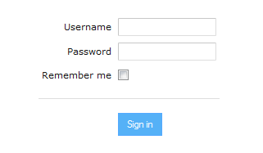
Figure 1: Login window
- Enter the user name and password provided by the system administrator and click Sign in.
For more information on OpenL Tablets WebStudio UI, see Introducing Rules Editor and Introducing Repository Editor. For more information on the single and multi-user modes, see Security Overview.

Modifying User Details
To manage user details, proceed as follows:
- In OpenL Tablets WebStudio, in the top-right corner of the window, click an arrow icon next to the username.
- In the actions list, click User Details.
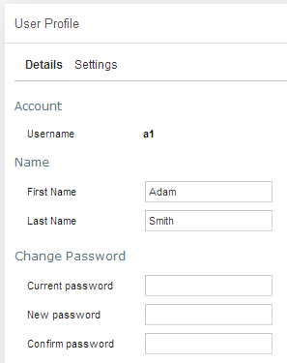
Figure 2: Viewing user details
- To update user’s first or last name, in the Name section, modify values as required.
- To update the password, in the Change Password section, enter the current and new password values.

Modifying User Settings
To manage user settings, proceed as follows:
- In OpenL Tablets WebStudio, in the top-right corner of the window, click an arrow icon next to the username.
- In the actions list, click User Settings.
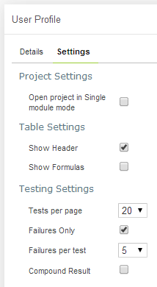
Figure 3: Viewing user settings
- To enable opening the project in the single module mode, in the Project Settings section, select the Open project… check box.
- In the Table Settings section, identify whether table header and formulas must be displayed.
- In the Testing settings, select values for displaying rule test results.
By default, all test results are displayed with five test tables, or unit tests, and compound result is not displayed. For more information on testing settings, see Run Tests.

Displaying the OpenL Tablets WebStudio Help
To display the OpenL Tablets WebStudio help topics, in OpenL Tablets WebStudio, in the top-right corner of the window, click an arrow icon next to the username and select Help.

Signing Out of OpenL Tablets WebStudio
To sign out of OpenL Tablets WebStudio, proceed as follows:
- In OpenL Tablets WebStudio, in the top-right corner of the window, click an arrow icon next to the username.
- In the actions list, click Sign out.
INCLUDEPICTURE "../../../../../Users/epoyasok/AppData/Local/Temp/SNAGHTML4890effb.PNG" \* MERGEFORMAT 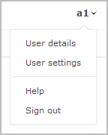
Figure 4: Signing out of OpenL Tablets WebStudio

Introducing Rules Editor
This section briefly introduces Rules Editor and includes the following topics:
- Rules Editor Overview
- View Modes
For more information on tasks that can be performed in Rules Editor, see Using Rules Editor.

Rules Editor Overview
Rules Editor enables users to browse rule modules and modify table data. This is the default editor opened when a user logs in. Rules Editor resembles the following:
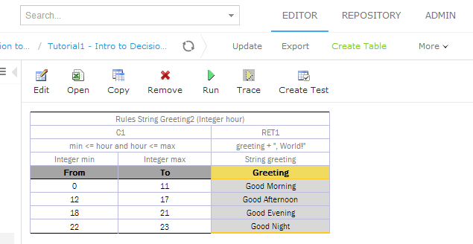
Figure 5: OpenL Tablets WebStudio Rules Editor
Rules Editor displays one module at a time. To switch between modules, select a module in the Projects tree or use breadcrumb navigation for quick switching between projects or modules of the current project.
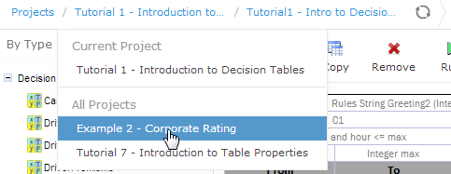
Figure 6: Rules Editor breadcrumb navigation
One rule project can contain several modules.
The following table describes Rules Editor organization:
Rules Editor organization
Pane | Description
Left pane | Displays the module tree providing a list of elements in the currently displayed rule module.
Middle pane | Displays contents of the table selected in the left pane and provides controls for modifying table data, running tests, and checking test results.
Right pane | Displays properties of the currently displayed table.
Upper part of the window | Contains toolbars with controls as described further in this section.
The following table describes the Rules Editor toolbar controls:
Rules Editor toolbar controls
Control | Description
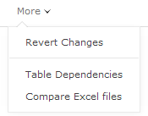 | The following table describes the available options:
  Option | Description
  Revert Changes | Opens a page for reverting module changes.
  Table Dependencies | Opens a graph displaying dependencies among tables of the module.
  Compare Excel files | Initiates a dialog for comparing Excel files.
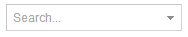 | Runs a simple search.  For more information on performing searches, see Performing a Search.
Switches the opening mode for a current module.
For more information on module opening modes, see Viewing a Module.
 | Refreshes OpenL Tablets WebStudio with the latest changes in Excel files.
 | Initiates the table creation wizard.
 | Displays recently viewed tables instead of the module tree.
 | Returns to the module tree view.
 | Sets the project status to Editing or Viewing.
 | Updates the current module or project with uploaded file or zip file. Exports the current version of module or project.
Switches user interface to repository editor.
For more information on repository editor, see Repository Editor.
Switches user interface to Rules Editor.
For more information on Rules Editor, see Rules Editor.
Switches user interface to the Administration mode.
For more information on administrative functions, see Administration.

View Modes
OpenL Tablets WebStudio provides the following modes for displaying rule elements:
Project display modes in Rules Editor
Mode | Description
Simple view | Project view is more business-oriented and displays only project elements relevant to the current business user. The tree structure is rather logical than physical. Rule tables are organized into categories based on the Category table property or, if the property is not defined, based on the Excel table sheet names.  An example of a module tree displayed in a simple view sorted by the Category parameter is as follows:  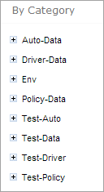  Figure 7: Module tree sorted by category  The By Category Detailed view displays modules sorted by the first value of the Category property. In the following example, the same module tree is sorted by Category Detailed. The modules that have the Auto-Data category are displayed in the Auto node and Data sub-node.  The modules with, for example, Calculation category value, are displayed in the Calculation node, Calculation sub-node as follows:  INCLUDEPICTURE "../../../../../Users/epoyasok/AppData/Local/Temp/SNAGHTMLb7c7591.PNG" \* MERGEFORMAT 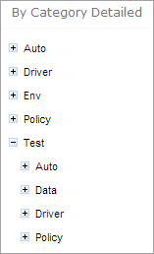  Figure 8:Module tree sorted by Category Detailed  The following example provides the module tree sorted by Category Inversed where the modules are sorted by the second value of the Category property:  INCLUDEPICTURE "../../../../../Users/epoyasok/AppData/Local/Temp/SNAGHTMLb7dc5df.PNG" \* MERGEFORMAT 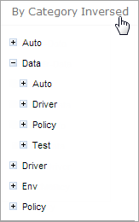  Figure 9:Module tree sorted by Category Inversed  Note that if the scope in a Properties table is defined as Module, in the By Category view, this table is displayed in the Module Properties sub-node as in the last example. If the scope is defined as Category, the table is displayed in the Category Properties sub-node.  OpenL Tablets WebStudio hides various technical table details when a table is opened in a simple view. An example of a table opened in a simple view is as follows:  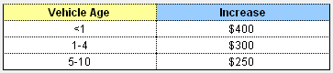  Figure 10: Rule table in a simple view  A user can switch to the simple view by clearing the Show Header check box in User settings.
Extended view | Extended view displays a project in a way convenient to experienced users, with module tree elements organized by type rather than logically.  An example of a module tree displayed in the extended view and sorted by type is as follows:  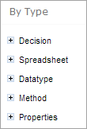  Figure 11: Module tree sorted by type  The following module tree is sorted By File and by spreadsheets within the file:  INCLUDEPICTURE "../../../../../Users/epoyasok/AppData/Local/Temp/SNAGHTMLbb6b223.PNG" \* MERGEFORMAT 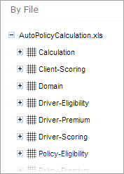  Figure 12: Module tree sorted by file  OpenL Tablets WebStudio displays various technical table details important for integration with code when a table is opened in the extended view. The following is an example of a table opened in the extended view:  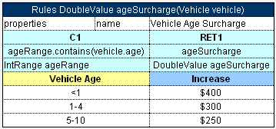  Figure 13: Rule table in the extended view  A user can switch to the extended view by selecting the Show Header check box in User settings.

Introducing Repository Editor
Repository editor provides controls for browsing and managing Design repository. A user can switch to repository editor by clicking the Repository control. Repository editor resembles the following:
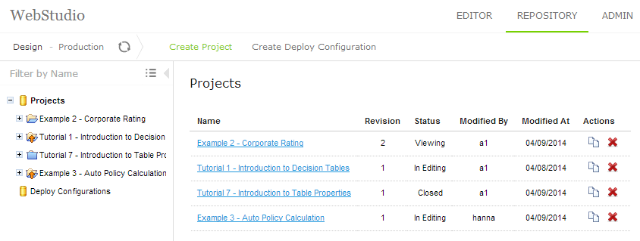
Figure 14: OpenL Tablets WebStudio repository editor
The following table describes repository editor organization:
Repository editor organization
Pane | Description
Left pane | Contains a tree of projects stored in Design repository and user's workspace. Unlike Rules Editor, repository editor displays physical project contents in terms of files and folders.
Middle pane | Displays content for the element selected in the tree.
The user can switch to Rules Editor by clicking the Rules Editor control.
For detailed information on tasks that can be performed in repository editor, see Using Repository Editor.

Using Rules Editor
This section describes the basic tasks that can be performed in Rules Editor. For more information on Rules Editor, see Rules Editor.
The following topics are included in this section:
- Filtering Projects
- Opening a Module
- Managing Projects and Modules
- Defining Project Dependencies
- Viewing Tables
- Modifying Tables
- Managing Range Data Types
- Creating Tables by Copying
- Performing a Search
- Creating New Table

Filtering Projects
To limit a list of projects displayed in the Projects list, start typing a project name in the field located above the list of projects.
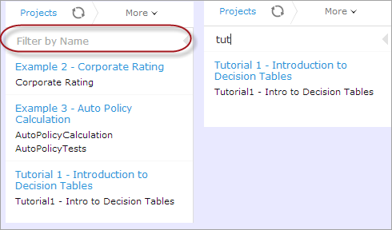
Figure 15: Filtering projects by Name
To get a full list of projects, delete filter text value in the field.

Viewing a Project
Rules Editor allows a user to work with one project at a time. To select a project, in the Projects tree, select the blue hyperlink of the required project name. The project page with general information about the project and configuration details appears in the middle pane of the editor.
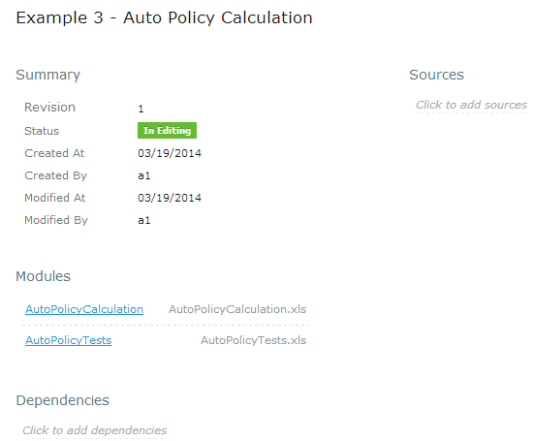
Figure 16: A project page in Rules Editor
If a particular project is not available, it must be opened as described in Opening a Project.

Viewing a Module
Rules Editor allows a user to work with one module at a time. To select a module, in the Projects tree, select the black hyperlink of the module name. The following module information is displayed:
- tree in the left pane displaying module tables
- general module information displayed in the middle pane, including project and module names, associated Excel file, number of tables, and module dependencies
If a particular module is not available, the project in which it is defined must be opened as described in Opening a Project.
To support convenient work with dependencies, the following modes for opening and viewing a module are available in OpenL Tablets WebStudio:
OpenL Tablets WebStudio mode opening and viewing modes
Mode | Description
Single-module mode | Displays the module considering only the module dependencies defined in the Environment table of the module and skipping any other modules of the current project and project dependencies. That is, the All Modules option is ignored.
Multi-module mode | Displays all modules of the current project with all their dependencies, that is, modules of projects defined as the project dependencies. In other words, the whole project with its infrastructure is opened.  Note that the module tree in the left pane displays the tables of a current module only, but, actually, tables of other project modules and project dependency modules can be accessed from any rule or test of the current module as well.
For more information on project and module dependencies, see the Project and Module dependencies section in [OpenL Tablets Reference Guide].
By default, modules of a project are opened in the multi-module mode. This is a common production mode.
To open a single module without complete project infrastructure, such as other project modules and project dependencies, to simplify or speed up rules development, for instance, change the project opening settings for each user individually in the user profile by selecting the Open project in Single module mode check box as described in Introducing Rules Editor.
To change the mode for a currently viewed module without updating user settings, select the required mode in the top line menu, in the module mode drop-down list.
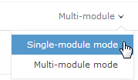
Figure 17: Modes of opening and viewing a module in OpenL Tablets WebStudio

Managing Projects and Modules
This section explains the following tasks that can be performed on projects in Rules Editor:
- Editing and Saving a Project
- Updating and Exporting a Project
- Exporting, Updating, and Editing a Module
- Reverting Module Changes

Editing and Saving a Project
A project can be opened for editing and saved directly in Rules Editor. Proceed as follows:
- To open a project in the Editing status, in the top menu, click Edit .
Note: If a project is in the Local status, this option is not available in Rules Editor.
- To save the edited project, click Save .
Note: If a project is in the Local status, this option is not available in Rules Editor.
- To modify the project in the Editing status, in the Project page, modify the values as described in the following table:
Editable project settings
Project details | Available actions
General project information and configuration, such as project name, description, and custom file name processor. | Put the mouse cursor over the project name and click Edit .  For more information on properties pattern for the file name, see the Properties from File Name section of [OpenL Tablets Reference Guide].
Project sources | Put the mouse cursor over the Sources label and click Manage Sources .
Modules configuration | Put the mouse cursor over the Modules label or a particular module name and click Add Module or Edit Module or Remove Module .
Project dependencies | Manage dependencies as described in Defining Project Dependencies.
All changes are saved in the project rules.xml file. For more information on this XML file, see [OpenL Tablets Developer Guide].

Updating and Exporting a Project
A user can
- To update a project directly in Rules Editor. The Update button is available for a project in the In Editing status in the top line menu.
- To export the project to the user’s local machine, for a project, in the top line menu, click Export. Exported project is downloaded as .zip archive.
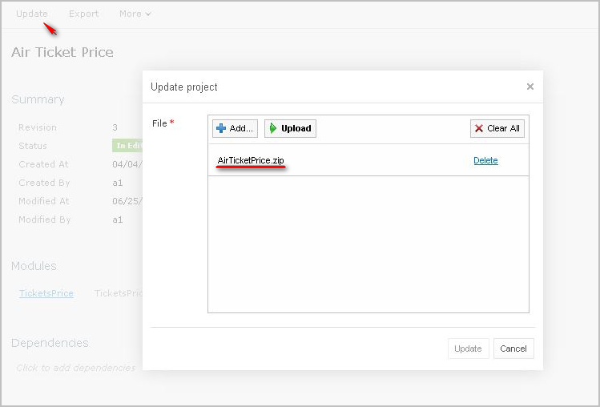
Figure 18: Importing and updating the project from .zip file

Exporting, Updating, and Editing a Module
A user can export, update, or edit a module directly in Rules Editor. Proceed as follows:
- To upload a changed module file , for a module, in the top line menu, click Upload.
- To export the module to the user’s local machine, for a module, in the top line menu, click Export.
Note: Modules can be exported only for the projects in the In Editing status.
- To modify module configuration, such as module name, path, and included or excluded methods, in the module page, put the mouse cursor over the module name and click Edit .
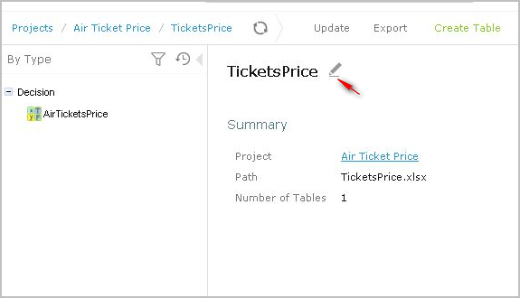
Figure 19: Initiating module editing
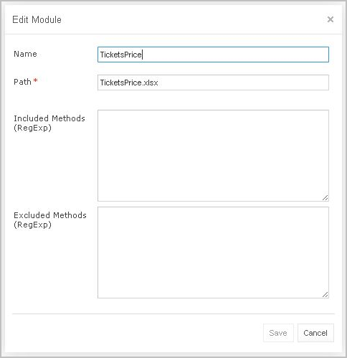
Figure 20: Editing module information
- To save the changes, click Save .

Reverting Module Changes
OpenL Tablets WebStudio allows comparing module versions and rolling back module changes against the specific date. Proceed as follows:
To compare module versions, select the desired module in the Projects tree and follow the steps below.
- In the Projects tree, select the module.
- In the top line menu, select More > Revert Changes.
The Revert Changes page appears displaying all module versions.
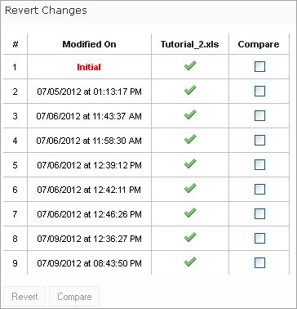
Figure 21: Displaying module versions
- To compare the changes, select check boxes for the required dates and click Compare.
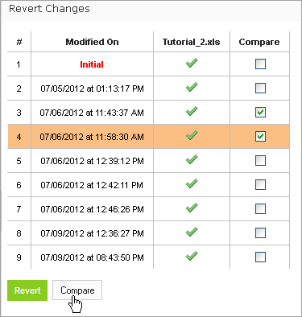
Figure 22: Comparing module versions
The system displays the module in a separate browser window where changed tables are marked as displayed in the following example.
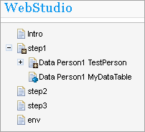
Figure 23: Tables with changes
- To view the changes, click the required table.
The result of the comparison is displayed in the bottom of the window.
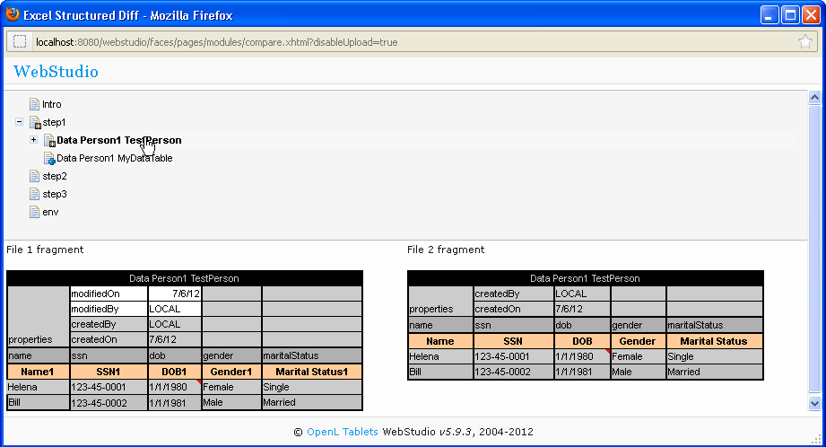
Figure 24: The result of the module version comparison
- To revert module changes, in the top line menu, select More > Revert Changes.
- Select the version the current version must be reverted with, click Revert, and confirm the changes.
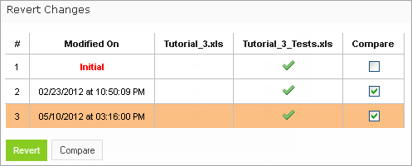
Figure 25: Reverting project changes

Defining Project Dependencies
A project dependency can be defined when a particular rule project, or root project, depends on contents of another project, or dependency project. Project dependencies are checked when projects are deployed to the production repository. OpenL Tablets WebStudio displays warning messages when a user deploys projects with conflicting dependencies.
To define a dependency on another project, proceed as follows:
- In Rules Editor, in the project tree, select a project name.
- If the project is not editable, make it editable as described in Editing and Saving a Project.
- Put the mouse cursor over the Dependencies label and click Manage Dependencies .
- In the window that appears, update information as required and click Save.
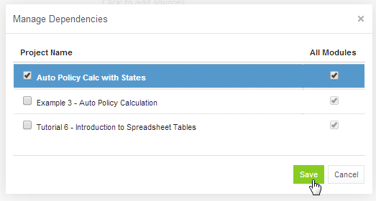
Figure 26: Managing project dependencies
If the All Modules option is selected in the multi-module mode, tables of all modules of the dependency project are accessible from any module of the root project.
If the All Modules option is cleared or the single module mode is selected, the root project module has access to the particular module of the dependency project only if an appropriate dependency is added in the Environment table of the root module.
Note: Module names of the root and dependency projects must be unique.
Note: Dependency projects must be available in Rules Editor to make dependency work.
For more information on project and module dependencies, see the Project and Module dependencies section in [OpenL Tablets Reference Guide].

Viewing Tables
OpenL Tablets module tables are listed in the module tree. Table types are represented by different icons in Rules Editor. The following table describes table type icons:
Table type icons
Icon | Table type
 | Decision table.
 | Decision table with unit tests.
 | Column match table.
 | Column match table with unit tests.
 | Tbasic table.
 | Tbasic table with unit tests.
 | Data table.
 | Datatype table.
 | Method table.
 | Unit test table.
 | Run method table.
 | Environment table.
 | Property table.
 | Table not corresponding to any preceding types. Such tables are considered comments.
 | Spreadsheet table.
For more information on table types, see [OpenL Tablets Reference Guide]. If a table contains an error, a small red cross is displayed in the corner of the icon.
To view contents of a particular table, in the module tree, select the table. The table is displayed in the middle pane. If the project is not in the In Editing status, the table can be viewed but cannot be modified.

Modifying Tables
OpenL Tablets WebStudio provides embedded tools for modifying table data directly in the web browser. To modify a table, proceed as follows:
- Ensure that the project is in the In Editing status as described in Editing and Saving a Project
- In the module tree, select the required table.
The selected table is displayed in the middle pane in the read mode.
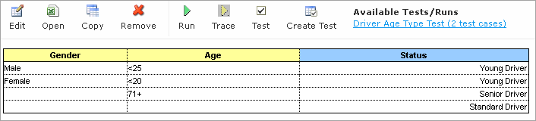
Figure 27: Table opened in OpenL Tablets WebStudio
- To switch between simple and extended view, in User settings, select or clear the Show Header and Show Formula options as required.
- To switch the table to the edit mode, perform one of the following steps:
- Above the table, click Edit.
- Right-click anywhere in the table and click Edit.
- Double click the cell to edit.
Note: The table cannot be switched to the edit mode if the project is not in the In Editing status.
Alternatively, the file can be edited in Excel. In the local mode, the rule file is opened in Excel, and changes become available in OpenL Tablets WebStudio upon Excel file saving. In the remote mode, the file must be saved locally and after modifying, uploaded directly in Rules Editor as described in Exporting, Updating, and Editing a Module or via the repository.
The following table is switched to the edit mode.
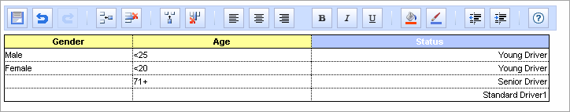
Figure 28: Table in the edit mode
The edit mode provides the following functional buttons:
Table editing buttons
Button | Description
 | Saves changes in table.
 | Reverses last changes.
 | Reapplies reversed changes.
 | Inserts a row.
 | Deletes a row.
 | Inserts a column.
 | Deletes a column.
 | Aligns text in currently selected cell with left edge.
 | Centers text in currently selected cell.
 | Aligns text in currently selected cell with right edge.
 | Make the text font bold.
 | Applies italics to the cell text.
 | Underlines the cell text.
 | Sets the fill color.
 | Sets the font color.
 | Decreases indent.
 | Increases indent.
 | Opens help.
- To modify cell value, double click it or press Enter while the cell is selected.
- To save changes, click Save .

Managing Range Data Types
OpenL Tablets WebStudio provides a special tool, Range Editor, for adding and editing range data types, such as IntRange and DoubleRange, in rule tables and test tables.
This section briefly introduces Range Editor and provides examples of its functionality.
The main Range Editor goal is to move to a single range format in OpenL rules, namely, the ‘..’ format. For more information on ranges on OpenL Tablets, see the Range types in Openl section in [OpenL Tablets Reference Guide].
Consider the following principles while working with Range Editor:
- The default range format is set to ‘..’ in OpenL Tablets WebStudio.
- When a new range is created, the ‘..’ format is used.
- When a range format other that ‘..’ is edited, if only range values are edited, the format remains the same.
If any editor control is used, for example, a check box or the Done button, the range format is set to ‘..’.
The following example displays the decision table with data represented as a range.
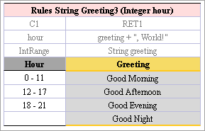
Figure 29: Decision table with a range data type
In this table, the Hour column contains hours with the IntRange Data type. All range sells are filled except for the last one. This example is used further in this section to demonstrate how Range Editor works.
The following controls are available in the Range Editor:
- From — indicates the left border of the range
- To — indicates the right border of the range
- Include — indicates whether the border is included in the range
- ‘>’ — indicates values greater than the specified border
- ‘<’ — indicates values smaller than the specified border
- ‘=’ — indicates a constant
- ‘-’ — indicates a range
To create a new range, proceed as follows:
- Double click the cell to be edited.
For example, edit the cell containing 18-21. The table is extended by the popup with a set of controls for editing the range.
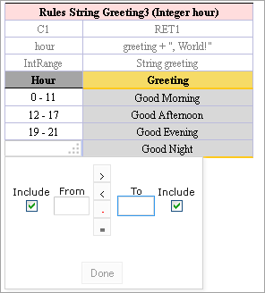
Figure 30: Creating a range in Range Editor – step 1
- In the From field, enter the left border of the range, which is 22 for the example described in this section.
- In the To field, enter the right border of the range.
In this example, the To value must be 24, but an erroneous value 23 is entered for further editing of this border.
- Clear the Include check box.
The result resembles the following.
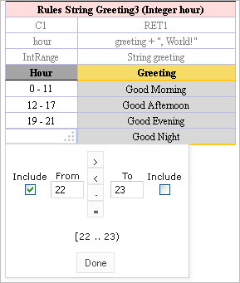
Figure 31: Creating a range in Range Editor – step 2
- Click Done to complete.
The last cell in the Hour column is filled as follows.
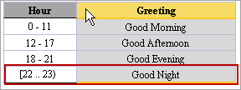
Figure 32: New range created in Range Editor
- To modify the range in Range Editor, double click the cell with the [22-23) range.
The table resembles the following.
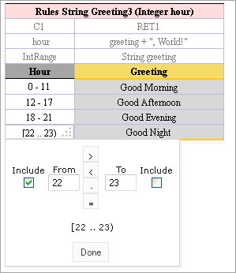
Figure 33: Editing a range in Range Editor
- Select the To field, set the right border to 24, and select Include.
- Click Done to save your work.
The range resembles the following.
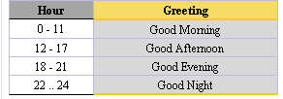
Figure 34: The range edited in Range Editor
A range can also be modified using ‘>’, ‘<’ and ‘=’ controls as described in the beginning of this section.

Creating Tables by Copying
A table can be created based on another table using one of the following methods:
- Copying the Existing Table
- Creating a New Version of the Table
- Creating a Table as a New Business Dimension Version

Copying the Existing Table
To create a table as a copy of the existing table, proceed as follows:
- In the module list, select a table to copy.
- Click the Copy Table icon .
The system displays the Copy Table form with New Table selected by default:
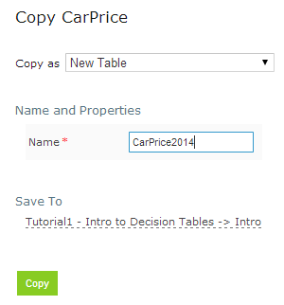
Figure 35: Copying the existing table
- If necessary, modify the Name field value.
- To change the workbook and worksheet where the copy will be saved, click the link in the Save To area and in the corresponding drop-down list, select the required module and category.
- To save the copied table in a new category, use the New option.
- Click Copy to save your changes.
The table appears in the module list.

Creating a New Version of the Table
To create a new version of the existing table, proceed as described in Copy as New Version. In that case, dimensional properties of a new version are exactly the same as for the original one. OpenL Tablets allows creating an overloaded table from an existing one.

Creating a Table as a New Business Dimension Version
To create a table as a new business dimension version, proceed as follows:
- In the module list, select a table and click the Copy Table icon.
- In the Copy as list, select New Business Dimension Version.
- Specify business dimension properties as required.
- If necessary, modify the workbook and worksheet values in the Save as area.
- Click Copy to save the table.

Performing a Search
OpenL Tablets WebStudio provides search functionality to look through all module tables data for a particular project. The following topics describe search modes in WebStudio:
- Performing a Simple Search
- Performing an Advanced Search

Performing a Simple Search
In the simple search mode, the system looks for a particular word or phrase in all tables within the given module.
To perform a simple search, in the Search field, enter a word or phrase and press Enter.
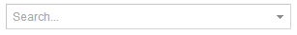
Figure 36: Starting a simple search
OpenL Tablets WebStudio displays all tables containing the entered text. Above each table, there is the Open Table in Excel link redirecting to the Excel file containing the entered text. The Edit Table link opens the table in Rules Editor in the editing mode.
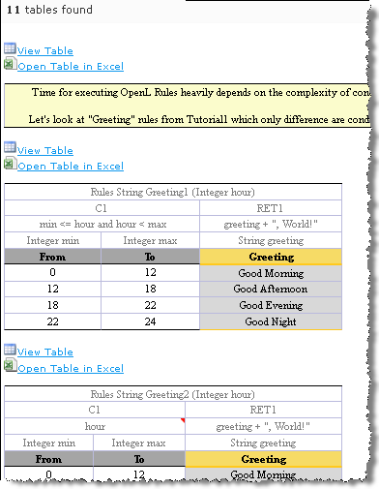
Figure 37: Search results
To search for any cell contents, right click the cell and in the context menu, select Search. The table must be opened in the read mode.

Performing an Advanced Search
Advanced search allows the user to narrow the search by specifying criteria for tables where the search is to be performed. To limit the search, specify one or several table types, text from the table header, and table properties as described further in this section.
- To start an advanced search, click the arrow to the right of search window.
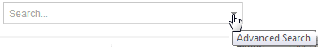
Figure 38: Initiating the advanced search
- In the filter form, click the Table Types field and select the required table type or select Select All to search in all table types.
- In the Header contains field, enter the word or phrase to search for.
- Expand the Table Properties list, select the required table property, and then click the Add button on the right.
The text field for entering the property name appears.
- Enter the property name.
- In the similar way, add as many table properties as required.
- To remove a property, click the cross icon to the right of the property.
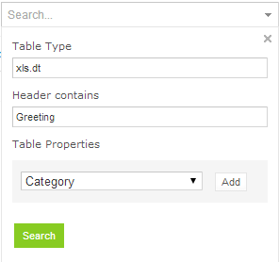
Figure 39: A filled form for advanced search
- Click Search to run the search.
As a result, the system displays the tables matching the search criteria along with links to the relevant Excel files and the Edit Table links leading to the table editing page.
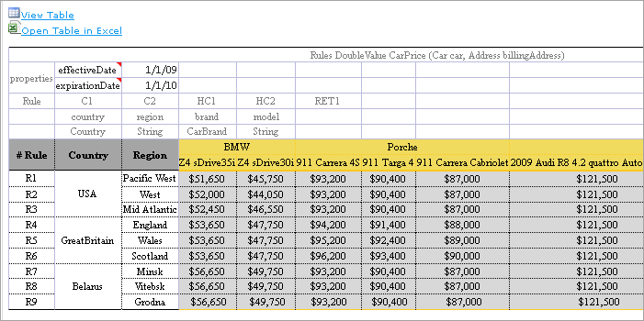
Figure 40: Advanced search result

Creating Tables
OpenL Tablets WebStudio allows creating tables of the following types:
- Datatype table
- Datatype Alias table
- Data table
- Test table
- Properties table
- Simple rules table
Tables are created via the wizard initiated by clicking the Create Table button . The wizard creates a table for the current module. The table is available for all included modules and modules linked by dependencies. For more information on dependencies, see the Project and Module dependencies section in [OpenL Tablets Reference Guide].
The following topics are included in this section:
- Creating a Datatype Table
- Creating a Data Table
- Creating a Simple Rules Table

Creating a Datatype Table
To create a Datatype table, proceed as follows:
- In WebStudio, click Create Table.
- In the list of table types, select Datatype Table and click Next.
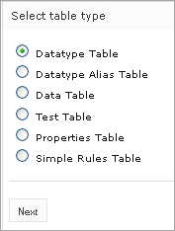
Figure 41: Creating a Datatype table
- Enter the data type name and if necessary, select the existing data type as a parent.
If a parent data type value is specified, the newly created data type will have access to all fields defined in the parent data type as described in the Inheritance in Data types section in [OpenL Tablets Reference Guide].
This option is unavailable if no custom data types are created in the module.
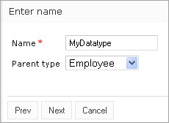
Figure 42: Specifying the data type name and parent type
- To define data type fields, click Add parameter, specify values as required, and then click Next.
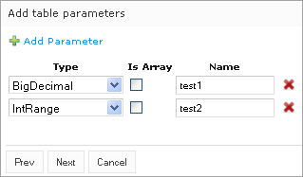
Figure 43: Defining data type fields
- To indicate new Datatype table location, in the Select destination window, specify the Category to which the table will belong.
The Module can’t be changed, all create tables goes to current module. In the Category section, select an existing sheet or in the New field, enter new sheet name.
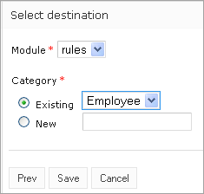
Figure 44: Specifying table location
- Click Save to complete table creation.
The Datatype table is created and becomes available in OpenL Tablets WebStudio.

Creating a Data Table
Creating a data table resembles creating a Datatype table described in Creating a Datatype Table. Proceed as follows:
- In WebStudio, click Create Table.
- Select the Data Table item in and click Next.
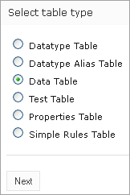
Figure 45: Initiating data table creation
- Select the table type, enter the table name, and click Next.
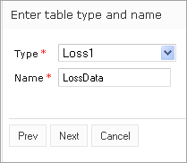
Figure 46: Defining table type and name
- Define the table columns configuration.
For the Loss1 type selected in the previous window, column configuration resembles the following.
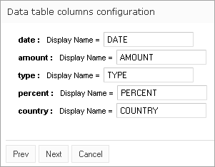
Figure 47: Defining column configuration
- To indicate new data table location, in the Select destination window, specify the module to which the table will belong.
The Module can’t be changed, all create tables goes to current module. In the Category section, select an existing sheet or in the New field, enter new sheet name.
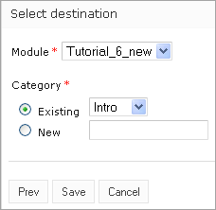
Figure 48: Specifying table location
- Click Save to complete table creation.
The new Data table is created and can be modified as needed.

Creating a Simple Rules Table
This section describes how to create a new simple rules table in OpenL Tablets WebStudio.
- In WebStudio, click Create Table.
- Select Simple Rules Table and click Next.
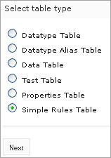
Figure 49: Initiating table creation
- Enter table name and select the required data type to return.
- Click Add Input Parameters and specify values as required.
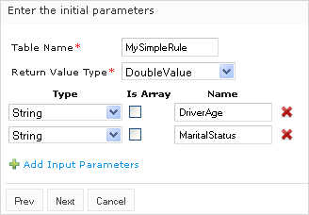
Figure 50: Specifying table parameters
- When finished, click Next.
In the Construct a table window that appears, a blank simple rules table with the header constructed based on the previously entered values appears.
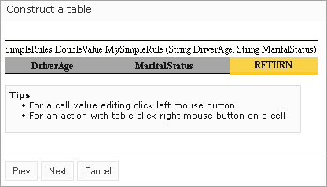
Figure 51: Adding data to a table
Now the table can be filled with data.
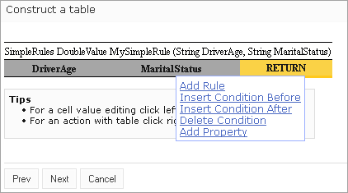
Figure 52: Selecting an action from the context menu
- Right click any cell and select one of the following actions:
Actions available for simple rules table
Action | Description
Add Property | Appears after selecting a property in the drop-down list and indicating its value.
Add Rule | Allows entering data. An example is as follows:  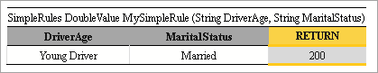  Figure 53: Entering table data  This action can be repeated as many times as required.
Insert Condition Before / Insert Condition After | Adds a condition column to the specified position. An example of the added DriverOccupation condition column is as follows:  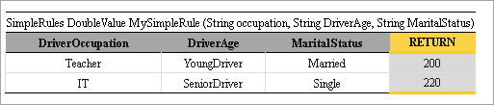  Figure 54: Adding a condition column
Delete Condition / Delete Rule | Removes a condition or rule.
- When finished, click Next.
- To indicate new table location, in the Select destination window, specify the module to which the table will belong.
The Module can’t be changed, all create tables goes to current module. In the Category section, select an existing sheet or in the New field, enter new sheet name.
- Click Save to save the changes.
The new simple rules table is created and appears in the project.

Editing and Testing Functionality
This section describes advanced OpenL Tablets WebStudio functions, such as table editing, performing unit tests, rule tracing, and benchmarking, and includes the following topics:
- Editing Tables
- Using Table Versioning
- Performing Unit Tests
- Tracing Rules
- Using Benchmarking Tools

Editing Tables
This section describes table editing and includes the following topics:
- Editing a Comma Separated Array of Values
- Editing Default Table Properties
- Editing Inherited Table Properties

Editing a Comma Separated Array of Values
WebStudio allows editing comma separated arrays of values. A multi selection window displaying all values appears enabling the user to select the required values.
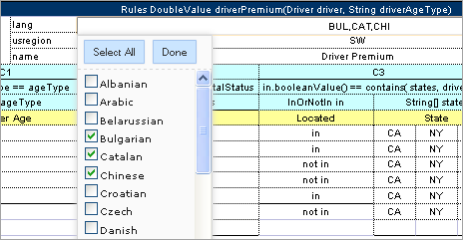
Figure 55: Editing comma separated arrays

Editing Default Table Properties
This section describes table properties available in OpenL Tablets WebStudio. For detailed information on table properties, refer to [OpenL Tablets Reference Guide], section Table Properties.
If default property values are defined for a table, they appear only in the right hand Properties section, but not in the table. In the example below, there are Active = true and Fail On Miss = false default properties.
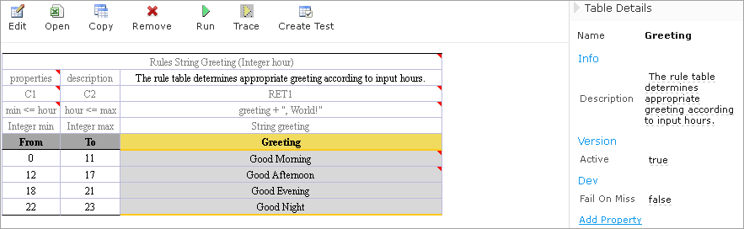
Figure 56: Default table properties example
Default properties can be overridden at the table level; in the other words, they can be changed as follows:
- In the Properties section, click the default property to be changed.
lnstead of the property value, a checkbox appears:
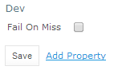
Figure 57: Updating a default property
- Select or deselect the checkbox as needed and click the Save button.
The property appears in the table with its new value:
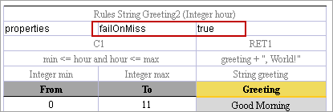
Figure 58: Default property was updated by a user

Editing Inherited Table Properties
Module or category level properties are those inherited from a Properties table as described in [OpenL Tablets Reference Guide], section Properties Table. In the Properties section of the given table, inherited properties appear in a different color and are accompanied with a link to the Properties table where they are defined. The values of the inherited properties are not stored in the table, they are displayed in the Properties section, since they are inherited and applied to this table. Inherited properties can be overridden at a Table level, i.e. they can be changed.
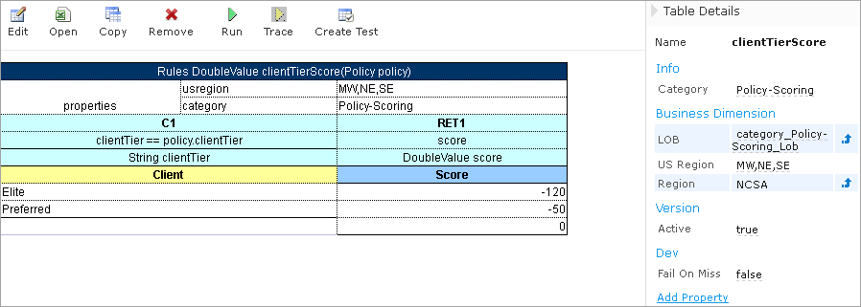
Figure 59: An example of inherited category-level properties
To change an inherited property, perform the following steps:
- In the Properties section, click the inherited property to be changed.
- Enter or select from the drop down list the desired values and click Save.
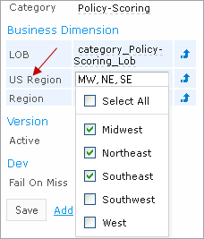
Figure 60: Updating an inherited property
The system displays the property in the table:
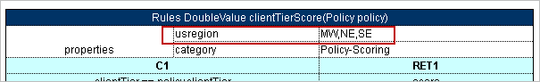
Figure 61: Inherited category-level property updated by a user
The following topics are included in this section:
- Editing System Properties
- Editing Properties for a Particular Table Type

Editing System Properties
By default, OpenL Tablets WebStudio applies system properties to each created or edited table. For information how to switch off this option, please refer to Common Settings. The values of the System properties are provided in the table and in the Properties section.
The modifiedBy property value is set using the name of the currently logged in user. The “modifiedOn” property is set according to the current date. These properties are applied upon each save and cannot be edited in the UI.
The “createdBy” property value is set using the name of the currently logged in user. The “createdOn” property is set according to the current date. These properties are only applied in the Multi mode, as described in Security Overview, on the first save only while creating or copying a table in OpenL Tablets WebStudio. The WebStudio users can delete those properties if required.
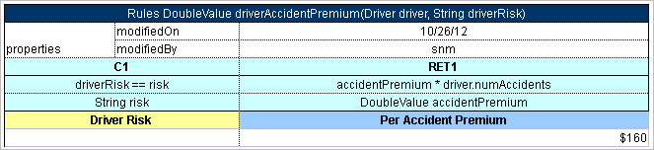
Figure 62: An example of system properties

Editing Properties for a Particular Table Type
Some properties are only applicable to particular types of tables. When opening a table in OpenL Tablets WebStudio, the properties section displays properties depending on the type of the table.
For example, such properties as Validate DT or Fail On Miss are available for Decision Tables. That means they can be selected from the drop down list after clicking the Add link at the bottom of the Properties section. The Figure below shows that properties applied to a Decision Table.
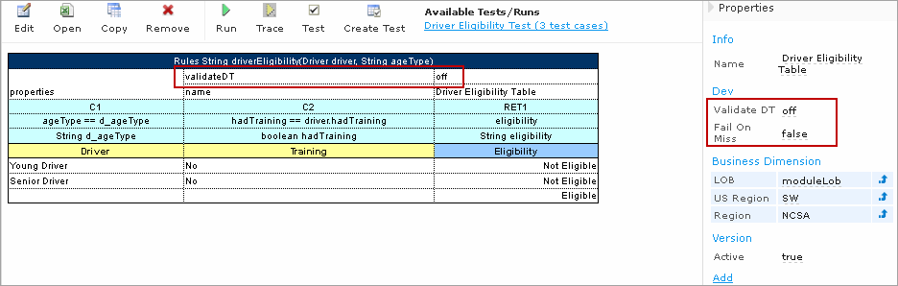
Figure 63: Properties for the Decision table type
When opening a Data Table in the same project, these properties are not available for selecting from the drop down list in the Properties section.
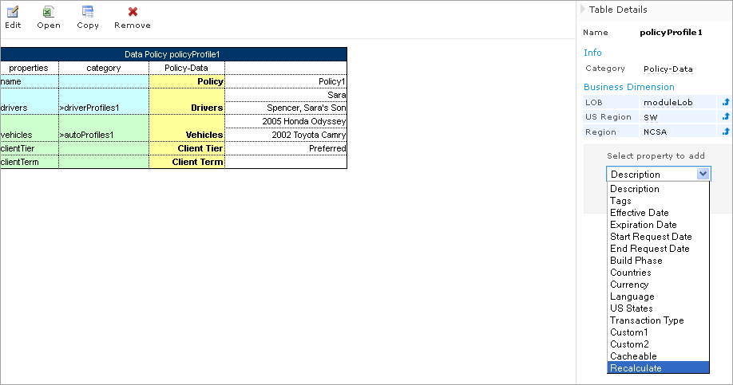
Figure 64: The Decision table properties that are not available for a Data table
When performing the “Copy” action, properties not suitable for the current table type, do not appear in the wizard.
To add a new property for the selected table, perform the following steps:
- In the Properties pane, click the Add link.
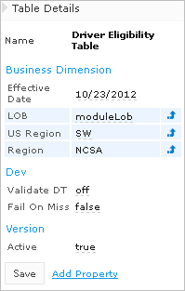
Figure 65: Add new property for the current table
- Enter the desired property or select it from the drop down list and click the Add button.
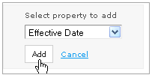
Figure 66: Selected table property to be added
- Specify the property value, and then click the Save button to complete.
All steps are collected in the Figure below.
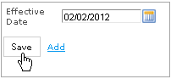
Figure 67: Saving a new property for the current table

Using Table Versioning
The table versioning mechanism is based on copying the existing table and is initiated in OpenL Tablets WebStudio by clicking the Copy button. Then select New Version in the Copy as list, enter the data as needed and click Copy to save .
A new table version has the same identity, that is, signature and dimensional properties of the previous version. When a new table version is created, the previous version becomes inactive since only one table version can be active at a time. By default, all tables are active. Below is an example of an inactive table version.
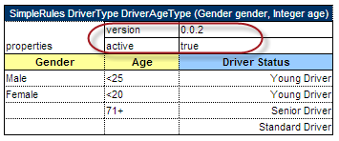
Figure 68: An inactive table version
Versions of the same table are grouped in the module tree under the table name. Clicking the table name displays the active version. If all tables are set to inactive, the latest created version is displayed.
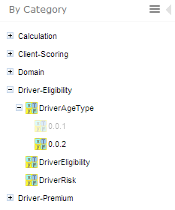
Figure 69: Displaying table versions in the module tree
The table version is defined in a three digit format, such as 4.0.1. Table versions must be set in an increasing order.
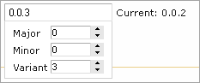
Figure 70: Entering a new version number

Performing Unit Tests
Unit tests are used in OpenL Tablets to validate data accuracy. OpenL Test tables with predefined input data call appropriate rule tables and compare actual test results with predefined expected results.
For example, in the following diagram, the table on the left is a decision table but the table on the right is a unit test table that tests data of the decision table:
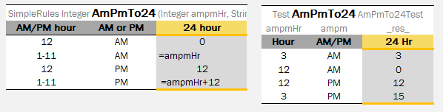
Figure 71: Decision table and its test table
OpenL Tablets WebStudio supports visual controls for creating and running project tests. Test tables can be modified like all other tables in OpenL Tablets WebStudio. For information on modifying a table, see Modifying Tables. Test results are displayed in a simple format directly in the user interface.
The following topics are included:
- Adding Navigation to a Table
- Running Unit Tests
- Creating a Test

Adding Navigation to a Table
WebStudio adds to table view navigation link to appropriate test table and vice versa. See below.
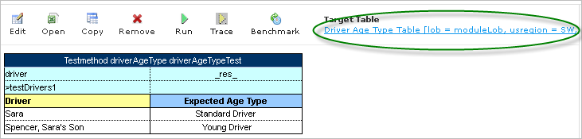
Figure 72: Navigation link to target table

Running Unit Tests
This section provides the methods used to run unit tests.
The following topics are included:
- Executing All Module Tests at Once
- Executing Tests for a Single Table
- Displaying Failures Only
- Displaying Compound Result

Executing All Module Tests at Once
The system automatically executes all test runs, test cases, in every unit test in a module, including tests in module dependencies, and displays a summary of results.
Note: If all tests are run in Multi-module mode, then the system executes all tests of the project, including project dependencies.
To run all module tests, click the Run Tests icon in the top line menu of Rules Editor.
Test results display resembles the following sample:
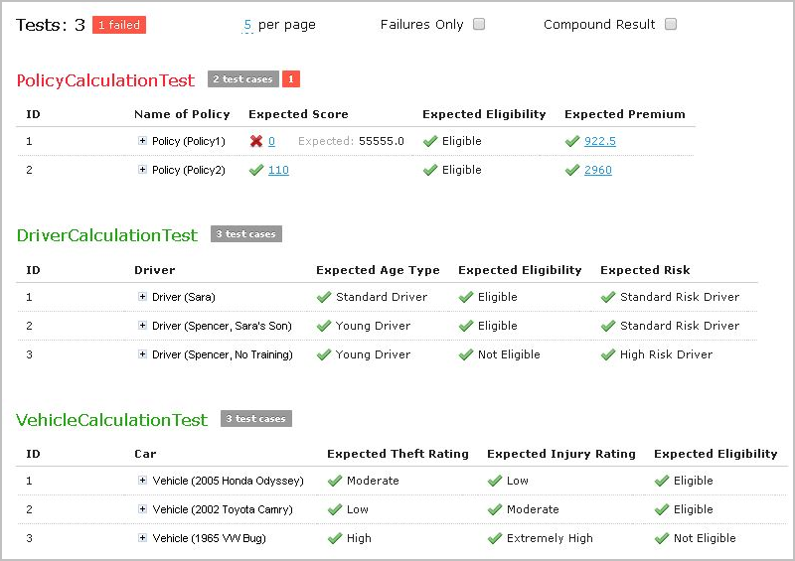
Figure 73: Results of running all project tests
Failed test cases are represented by mark. Passed tests are represented by mark.
On the example above test results are displayed with five test tables, unit tests, per page. This setting is configured for each user individually in User Profile as “Tests per page” setting.
To change the setting for a particular test run without updating user settings, click the arrow to the right of the Run Tests and choose a desired number of “Tests per page”. There is an alternative way: the same setting options are displayed on the top of the window after executing all tests. The picture below provides an illustration:
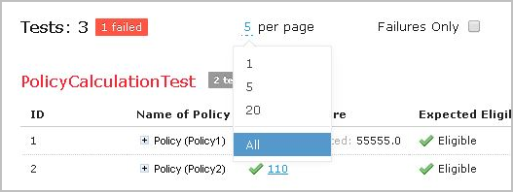
Figure 74: Number of tests per page setting

Executing Tests for a Single Table
To execute all test runs for one particular rule table, proceed as follows:
- in Rules Editor, in the module tree, select the rule table and, in the upper part of the middle pane, click Test .
Test results resemble the following:
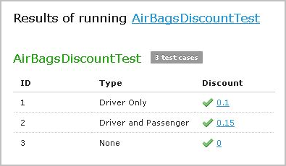
Figure 75: Results of executing all test runs for one rule table
To test a rule table even if no tests have been created for the given table yet, perform the following steps:.
- Select the desired rule table in the module tree and click the green Run arrow above the table.
The form for entering required values to test rule table appears:
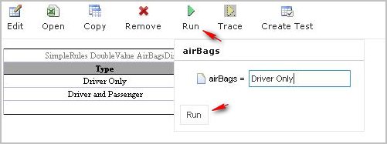
Figure 76: Testing a rule table without tests
- In the popup window, click the Run button.
The results of the testing are displayed:

Figure 77: Result of running virtual test
For Test tables, the system enables to select test cases to be executed. Proceed as follows:
- Navigate to the Run button above the Test table and click the small black arrow 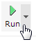.
- The popup appears where users can choose from the test cases and only run necessary tests.
Select or clear the check-boxes for appropriate ID`s or define your own _id_ column is appropriate Test table, and in case of need to run several particular test cases – define them in field ‘Use the Range’, as needed:
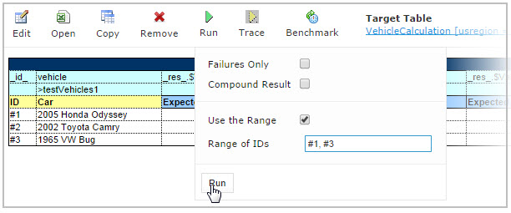
Figure 78: Select test cases via Range field to be executed
- Click the Run button within the popup.
Only selected test cases will be executed:
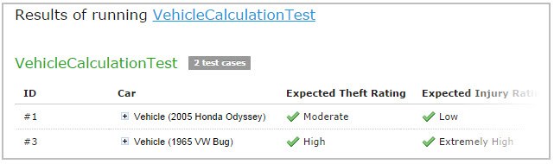
Figure 79: Result of selective testing

Displaying Failures Only
There are cases when a user wants to examine results of failed test cases only. For example, the project contains a test with more than 50 test cases and the user just needs to know whether project rules are operating correctly, it means all test cases are passed. If a user runs the test, they will get a huge table of results which are difficult to review and find failures to correct the rule or case. For such situations WebStudio provides an option to display failed test cases only.
This option is configured for each user individually in User Profile as “Failures Only” setting. To change the setting for a particular test run without updating user settings, there are multiple ways:
- Click the arrow to the right of the Run Tests and (un)check “Failures only” in an displayed popup form.
- Select the Test table and navigate to the Run button above the table and click the arrow 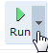. (Un)check “Failures only” in the displayed popup form.
- (Un)check “Failures only” setting which appears on the top of the window after executing all tests at once.
See Figure: Number of tests per page setting.
Additionally, the number of failed test cases to be shown for one unit test can be limited. For example, the user is testing rules iteratively – he/she is interested just in the first several failures in order to analyze the first ones, correct and execute tests again, sequentially correcting errors. To do this, change “All” on an appropriate value next to “Failures per test” label or “first” label (for way 3). The setting is available only if “Failures only” is checked:
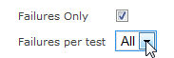
Figure 80: Settings for displaying failed test cases only

Displaying Compound Result
The result of a rule table execution can be a single value or compound value such as spreadsheet. A test table specifies what is tested, full result or particular parts of it, and their expected results of each test case. For example, IncomeForecastTest below is intended to check Minimal and Maximal Total Salary values in the resulting spreadsheet:
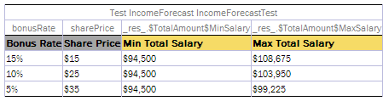
Figure 81: Testing tables with compound result on
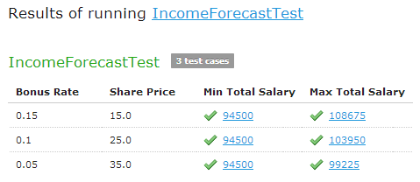
Figure 82: Testing spreadsheet result
After running the test, OpenL Tablets WebStudio displays each test case with input values and actual results marked as passed or failed.
In cases when test result is complex (compound), there is an option to display the full result of running test cases as well, not only values which are being tested. It is configured for each user individually in User Profile as “Compound Result” setting. If the option is switched on, the result of running IncomeForecastTest looks as follows:
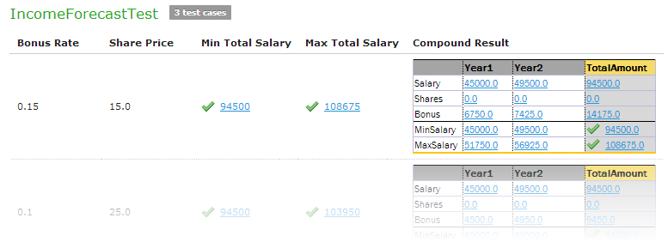
Figure 83: Displaying compound result
This setting for a particular test run (without updating user settings) can be changed in the same ways as it is described in Displaying Failures Only.

Creating a Test
WebStudio provides a convenient way to create a new test table.
After an executable table (Decision, Method, Test, Run, Spreadsheet) is created, the Create Test item is available.
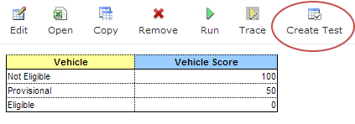
Figure 84: Create new test table
To create a Test table for the current table, click the Create Test button. WebStudio suggests a two step wizard which helps to create an appropriate Test table.

Tracing Rules
OpenL Tablets WebStudio provides a rule tracing view for all appropriate OpenL Tablets methods. These methods include the following:
- All unit tests
- All Rule tables with the possibility of specifying input parameters and tracing any method
- Run Method tables with preset parameters
Rule tracing enables users to determine how results for complex rules are obtained.
IMPORTANT! Users must make sure their browser does not block pop-up windows. Otherwise, trace results will not be seen. For information how to unblock pop-up windows, refer to the specific browser Help.
Using the tracing functionality, users can check the result of each step of the rule and how the result was obtained without creating test cases. For that, perform the following steps:
- In Rules editor, open a rule table to be traced and click Trace in the middle pane.
- Enter parameters to be traced in the popup window:
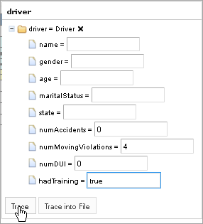
Figure 85: Tracing a rule for a rule table
- Click the Trace button.
If there is a set of test cases and the result of each step of the rule and how the result was obtained need checking, trace the Test table as follows:
- Open the desired Test table and hover the mouse pointer over the Trace button.
- To open a popup with test cases to be traced, click the small right-hand black arrow.
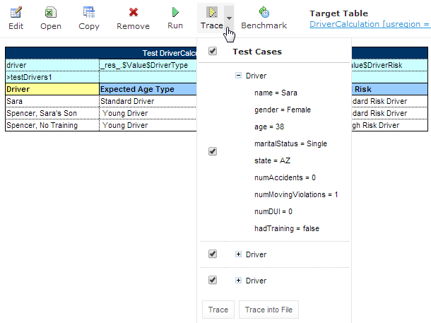
Figure 86: Run tracing for a Test table
- In the popup, select or deselect the test cases as needed.
By default, all cases are selected. All test cases can be checked or unchecked by using the checkbox on the left of Test Parameter(s).
- Click Trace to start the process.
The system displays the tracing results in a separate browser window as illustrated below.
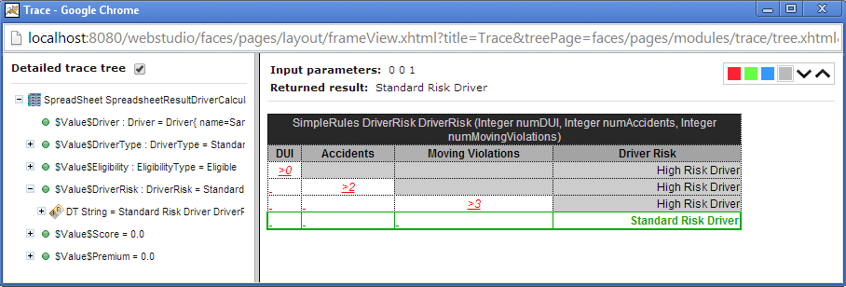
Figure 87: Tracing results
The left side displays a tree consisting of rule tables as tree nodes and fired rule rows as tree leaves. Selected Detailed trace tree option enables to view all rule calls.
- If that option is cleared, only successful calls will be displayed.
This option can only be used for a Decision table or if a Decision table is used in complex rules.
- If an element in the tree is selected, the corresponding rule table is displayed in the right pane.
The fired rule rows are highlighted using the specified color. The highlight color and transparency level can be configured by clicking the buttons above the rule table. Note that the gray button is selected by default.
In addition, the right pane displays the actual parameters used in the particular rule call and the returned result.
The example above demonstrates the results of tracing Decision table. For other rule tables, the picture slightly differs but the meaning is essentially the same.
For a Decision table the tracing results are shown as follows:
- The rules that were traced are not highlighted and appear as white rows.
- Successfully completed or returned rules are boxed with green lines.
- The failed rules are displayed in red.

Using Benchmarking Tools
OpenL Tablets WebStudio provides benchmarking tools for measuring execution time for all appropriate OpenL Tablets elements. In OpenL Tablets, everything that can be run, can be benchmarked too. Benchmarking is useful for optimizing the rule structure and identifying critical paths in rule calculation.
The benchmarking icon is displayed above the table to be traced.
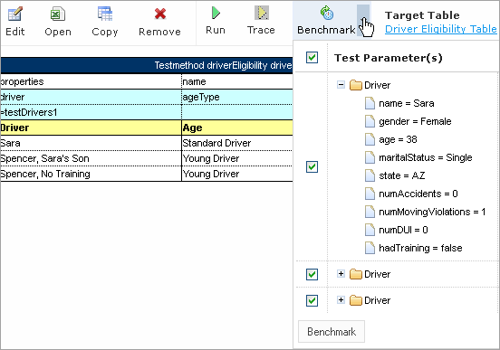
Figure 88: Controls for measuring performance
For a Test table, select the test cases as follows:
- Open the desired Test table.
- Navigate to the Benchmark button above the Test table and click the small right-hand black arrow to open a popup with test cases as needed.
- Select or deselect the test cases as needed.
By default, all cases are selected. All test cases can be also checked or unchecked by using the checkbox on the left of Test Parameter(s).
- Click the Benchmark button within the popup.
Clicking the benchmarking icon runs the corresponding method or set of methods and displays the results in a table.
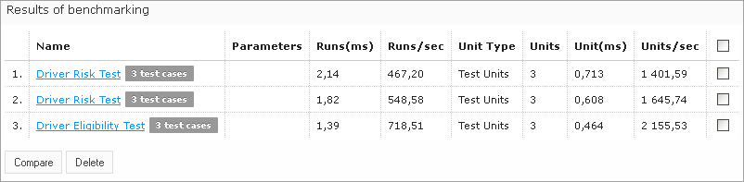
Figure 89: Benchmarking results
OpenL Tablets WebStudio remembers all benchmarking runs executed within one session. Every time a new benchmark is run, a new row is added to the results table.
Benchmarking results can be compared to identify the most time consuming methods. Select the required check boxes and click Compare to compare results in the results table.
Comparison results are displayed below the benchmarking table.
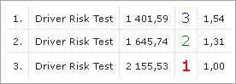
Figure 90: Comparing benchmarking results

Using Repository Editor
This section describes tasks that can be performed in repository editor. For general information on repository editor, see Introducing Repository Editor.
The following topics are included in this section:
- Browsing Design Repository
- Filtering the Project Tree
- Creating Project in Design Repository
- Opening a Project
- Closing a Project
- Editing a Project
- Saving a Project
- Modifying a Project
- Copying a Project
- Removing a Project
- Deploying Projects
- Comparing Project Versions
- Exporting a Project
- Unlocking a Project

Browsing Design Repository
Repository editor displays all projects in user's workspace and Design Repository. The project tree is organized into the following categories:
Categories in the project tree
Category | Description
Projects | Contains OpenL Tablets rule projects.
Deploy Configurations | Contains deploy configurations for deploying rule projects to Production Repository. For information on using deploy configurations, see Deploying Projects.
The status of each project in the tree is identified by a specific icon. The following table describes the icons in the project tree:
Project icons in repository editor
Icon | Description
Project is closed.
It is available only in Design Repository and must be opened to copy it to user's workspace.
Project is opened for viewing.
It is copied to user's workspace in read-only mode and must be moved to the Editing status for modification.
Project is edited by the current user.
It is copied to user's workspace and can be modified. Other users cannot edit the project. To save changes, the project must be saved.
Project is closed by the current user but edited by another user (Closed - Locked).
Current user cannot edit the project.
Project is opened for viewing by the current user but edited by another user (Opened - Locked).
Current user cannot edit the project but can browse the project in the Rules Editor.
Project exists only in user's workspace but not in Design Repository (Local).
Other users do not see this project. User can delete the project or import it into Design Repository as described in the Creating Projects in Design Repository.
Project is marked for deletion.
In OpenL Tablets WebStudio, deletion of a project takes place in the following phases:
Phase | Description
Deleting a project | Project is removed from user's workspace and marked for deletion. In this phase, the project can be restored using the undelete function.  For information on deleting a project, see Deleting a Project.
Erasing a project | Deleted project is permanently removed from Design Repository. After this phase, the project cannot be restored.  For information on erasing a project, see Erasing a Project.

Note: Some projects may have two names displayed in the Project tree: logical name and then physical name in brackets. It happens when name defined in rules.xml of the project (logical name) differs from original project name from file system (physical name).

Filtering the Project Tree
Projects in the Repository editor are filtered the same way as in the Rules Editor. To filter projects by name, enter the name in the filter text box. All projects matching the name are displayed in the Projects list.
An advanced filter can be also applied to the project tree so that only files of particular types are displayed.
- Click the Advanced Filter icon to the right of the filter text box.
- In the Advanced Filter pop up window, enter a list of file extensions, separated by semicolon as follows:
xls;properties;txt.
- Select the Hide deleted projects option if required.
- Click Apply.
The project tree is filtered so that only files of the specified extensions are displayed. Project folders are always displayed.
Note: To reset the filter, clear the previously entered file extensions and click Apply.

Creating Projects in Design Repository
OpenL Tablets WebStudio allows users to create new rule projects in the Design Repository in one of the following ways:
Ways of creating new rule projects
Way | Section
Create an new rule project from template | Creating a Project from Template
Create a rule project from Excel files | Creating a Project from Excel Files
Create a rule project from zip archive | Creating a Project from ZIP Archive
Import a rule project from workspace | Importing a Project from Workspace
Create a custom project template | Creating a Custom Project Template
Whatever the way used, new projects are created in the Editing status that means they are open and can be modified.

Creating a Project from Template
This is the easiest way to create a rule project in the Design Repository that must be preferably used for demonstration or introductory purposes.
While creating a project from template, use the following template types:
Template types
Template type | Description
Simple Templates | Include the following:  - Sample Project — a very simple project consisting of one rule table and hence, one Excel file.  - Empty Project — allows to create a project with an empty Excel file. Open the project and create tables as needed.
Examples | Provide several simple projects demonstrating how OpenL Tablets can be used in various business domains.
Tutorials | A number of projects designed to familiarize users with OpenL Tablets step-by-step, from simple features and concepts to more complex ones.
Projects represented as Examples and Tutorials can be used not only to learn how they are organized and work, but also to create user’s own projects from them.
To create a new project from template, proceed as follows:
- In the top line menu, click Create Project.
The Create Project from window appears.
- Clicks the Template tab.
Note: This tab is normally selected by default.
All project templates are organized into three areas: Simple Templates, Examples and Tutorials described above in this topic.
- Navigate to the desired template and click its name.
The name appears in the Project Name field. An example below demonstrates creating a Simple project.
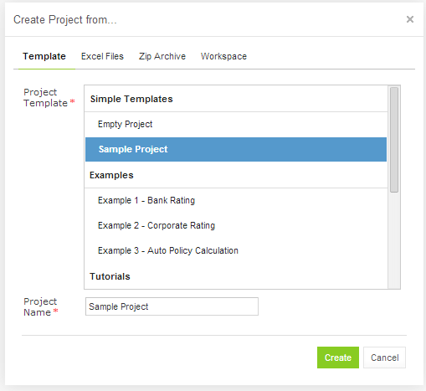
Figure 91: Creating Simple project from template
Use the name provided or enter a custom name if needed.
- Click Create.
A new project is created in Design Repository. Initially, project structure corresponds to the selected project template but can be constructed manually.
- To construct the project structure, add folders and upload files as described in Modifying Project Contents.

Creating a Project from Excel Files
A rule project in the Design Repository can be created by loading one or more Excel files that contain OpenL rule tables or entire rule projects.
Proceed as follows:
- Click Create Project in the top line menu.
- In the Create Project from dialog, click the Excel Files tab.
- Click the Add button, locate the desired Excel file in a file system and click Open.
- If required, repeat the previous step to add more files for the project.
All files will be listed in the File area.
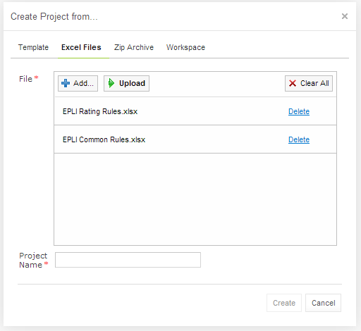
Figure 92: Creating a project from Excel files
A file can be removed from the list by clicking the corresponding Delete link. To delete all files, click Clear All.
- After adding all the required files, click Upload to load the files into the repository.
Each file can be uploaded separately but it is not recommended.
- In the Project Name field, enter the name by which the project must be represented in the Design Repository.
- Click Create to complete.

Creating a Project from ZIP Archive
OpenL Tablets WebStudio provides a control for loading rule projects archived in a ZIP file into Design Repository. The procedure is similar to creating a project from Excel files described above although there are a few differences.
- Click Create Project in the top line menu.
- In the Create Project from dialog, click the Zip Archive tab.
- Click the Add button, locate the desired zip archive and click Open.
The file can be seen in the File area.
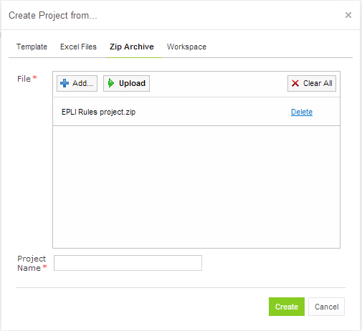
Figure 93: Creating a project from ZIP file
- Click Upload to proceed.
- Project Name text box is automatically populated with the project name defined in rules.xml, if the uploaded ZIP file contains rules.xml, or with the file name.
The name can be changed and it will be updated in rules.xml accordingly.
- Click Create to complete.

Importing a Project from Workspace
A new project can be created in the Design Repository by loading a project with the Local status from user workspace.
- Click Create Project in the top line menu.
- In the Create Project from dialog, click the Workspace tab.
The system displays rule projects available in the workspace:
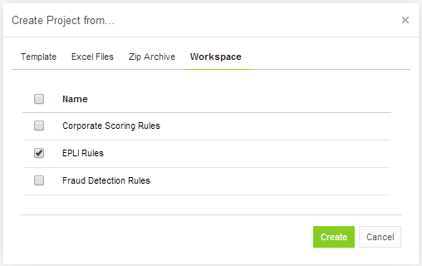
Figure 94: Creating a project from Workspace
- Select checkboxes for projects to be uploaded and click Create to complete.
In case projects are loaded successfully, an appropriate notification displays.

Creating a Custom Project Template
It is possible to create a custom project template that will be used in the future during new projects creation.
To create a new custom project template, proceed as follows:
- If the webstudio home directory is c:\openl create the following directory: c:\openl\project-templates.
- Create a subfolder with a template category name.
Example: c:\openl\project-templates\My Custom Templates.
- Create subfolders with templates that contain files with templates.
For example:
c:\openl\project-templates\My Custom Templates\Simple Rating Project\rating.xlsx
will be presented as "Simple Rating Project" inside the category "My Custom Templates" containing the rating.xlsx file.
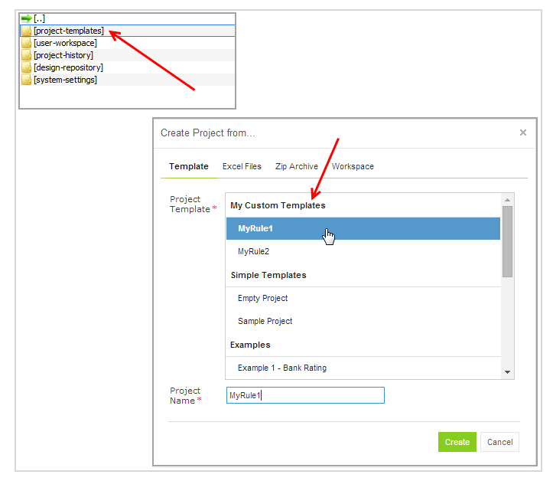
Figure 95: Creating custom project template

Opening a Project
An opened project is copied to user's workspace and becomes available for selection in Rules Editor. The project is opened for viewing and cannot be modified, it must become Editable as described in Editing a Project for modification.
To open a project, in the project tree, select the project and, in the right pane, click one of the following buttons as required:
Buttons for opening a project
Button | Description
Open | Opens the latest revision of project.
Open Revision | Displays window where a user can specify which project revision must be opened.
Any project revision can be opened from the Revisions tab. For that, select the project in the Projects tree and proceed as follows:
- Click the Revisions tab.
A list of revisions appears.
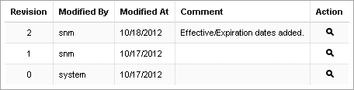
Figure 96: List of project revisions
- Navigate to the revision that needs to be opened and click the corresponding magnifier icon in the Action column.
- Click OK in the information message.

Closing a Project
Closing a project deletes it from the user's workspace. No changes made to the project will be applied and stored. From that point, the project is not available for selection in the Rules Editor. Users can still browse closed projects in the Repository Editor.
To close a project, in the project tree, select the project and, in the right pane, click Close.

Editing a Project
An editable project, when the project status is In Editing, is copied to user's workspace, becomes available for selection in Rules Editor and can be modified. Only editable project can be modified in the Rules Editor. To apply changes made to a project, the project must be saved as described in Saving a Project.
To make a project editable, in the project tree, select the project and, in the right pane, click In Edit.
The latest project revision is becomes editable even if the user previously opened an older project revision.
Alternatively, an opened project can be made editable directly from Rules Editor as described in Editing and Saving a Project.

Saving a Project
A modified project is saved and copied from the user's workspace to Design Repository as a new revision.
To save a project, proceed as follows:
- In the project tree, select the project, and, in the right pane, click Save.
The Save changes window appears.
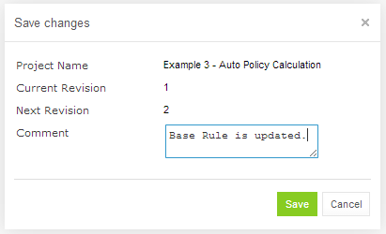
Figure 97: Save changes in a project
The number of a revision is updated automatically and specified in the Next Revision field.
- Enter comments if needed and click Save.
An editable project can be saved and closed directly from Rules Editor as described in Editing and Saving a Project.

Modifying a Project
For an editable project, users can modify the project’s properties and content.
The following topics are included in this section:
- Modifying Project Properties
- Modifying Project Contents

Modifying Project Properties
Each rule project has a set of properties displayed in the Properties tab when a project is selected.
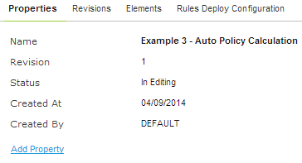
Figure 98: Project properties
Some properties such as Name, Crated At / Created By, etc. are updated automatically by the system, and users cannot edit them in the WebStudio UI. The others can be specified for editable projects using the Add Property link as described in Adding Business Dimension Properties.
The following topics are included in this section:
- Adding Business Dimension Properties
- Adding Custom Properties

Adding Business Dimension Properties
Users can add Business Dimension properties predefined in a drop down list.
To add a Business Dimension property to a project, perform the following steps:
- Select the project in the Projects tree.
- In the Properties tab, click the Add Property link.
- Select the desired property from the drop down list and click Add:
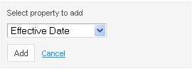
Figure 99: Add a project property
- Specify the value as needed and click the green tick on the right to save changes:
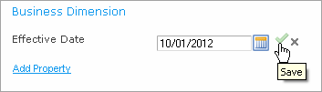
Figure 100: Save a new project property

Adding Custom Properties
The list of project properties available in the drop down list can be extended by adding Custom Properties.
To add Custom properties, proceed as follows:
- Open the <tomcat directory>\webapps\webstudio\WEB-INF\conf\repository-artefact-props.properties file for editing.
- Enter the list of attributes to add to UI, delimited by comma, for example:
props.use = attribute1, attribute6, attribute7, attribute13
The following table describes types of attributes that can be added to UI:
Project properties that can be added to drop down list in UI
Property | Description
attribute 1 - attribute 5 | String properties.
attribute 6 - attribute 10 | Date properties.
attribute 11 - attribute 15 | Number properties.
- Uncomment the attributes to be added as Custom properties by removing an appropriate ‘#’, and define the properties’ names, for example, as shown in the following snippet:
props.attribute1 = Additional String Property
props.attribute7 = Additional End Date
props.attribute13 = Additional Number
If a property name is not defined, the property appears in drop down list and UI with its sequential number, such as attribute 6.
For example, if properties 1, 6, 7 and 13 are added, they appear in the drop down list as follows:
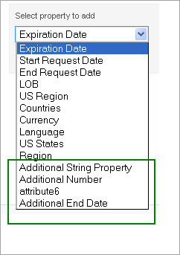
Figure 101: Customer properties 1, 6, 7 and 13 are shown in the green box
Add Customer properties in the same way as described in Adding Business Dimension Properties. The next Figure illustrates properties 1, 6, 7 and 13 as they appear in the project UI.
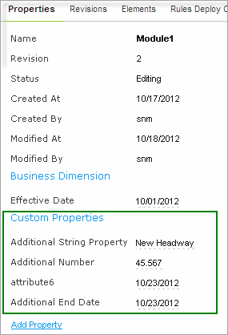
Figure 102: Project UI with properties 1, 6, 7 and 13 added

Modifying Project Contents
This section describes modifying the physical structure of the project.
The following topics are included in this section:
- Creating a Folder
- Uploading a File
- Updating a File
- Deleting a Folder or a File

Creating a Folder
To create a new folder in the project structure, proceed as follows:
- If the project is not editable, make it editable as described in Editing a Project.
- In the project tree, select the parent folder in which the new folder must be created.
To create a root level folder, the project name must be selected in the project tree.
- In the right pane, click Add Folder.
- In the Add Folder window, enter the folder name and click Add.

Uploading a File
To upload a file to a project folder, proceed as follows:
- If the project is not editable, make it editable as described in Editing a Project.
- In the project tree, select the folder where the file should be uploaded.
To upload a file to the root level, the project name must be selected in the project tree.
- In the right pane, click Upload File.
The Upload File window appears.
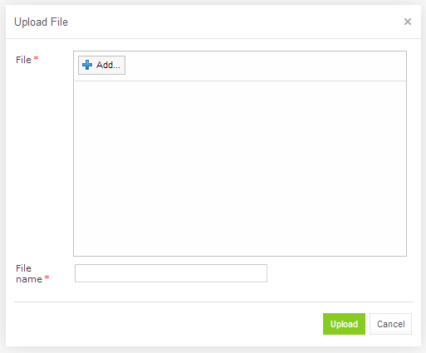
Figure 103: Uploading a file
- Click Add in the File area and select the file to be uploaded.
- Click the upper Upload button (with a green arrow).
- In the File name field, enter or modify the name of the file to be used in the Design Repository.
- Click the Upload button at the bottom.

Updating a File
To update a file of a project via repository editor, proceed as follows:
- If the project is not editable, make it editable as described in Editing a Project.
- In the project tree, select the file to be updated and, in the right pane, click Update file.
- In the window that displays, click Add and choose a required file for updating.
- Click the Upload button to load the file.
- Click Update to end the action.

Deleting a Folder or a File
To delete a folder or a file in the project structure, proceed as follows:
- If the project is not editable, make it editable as described in Editing a Project.
- Perform one of the following steps as required:
- Expand the project tree, select the folder or file to be deleted and, in the right pane, click Delete.
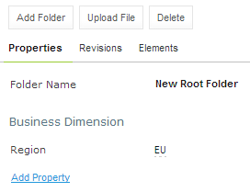
Figure 104: Deleting a project element
- To delete an element inside the parent folder, select that folder, click Elements to expand the folder and then click Delete at the right of the item to be deleted.
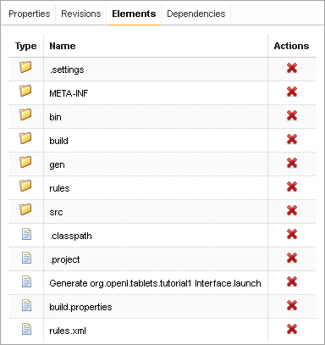
Figure 105: Deleting project elements from the Elements tab
- Click OK In the confirmation window.

Copying a Project
Copying a project creates a new project with identical contents and a different name in the Design Repository. This function can be used for copying local projects to the Design Repository with a different name.
To copy a project, proceed as follows:
- Perform one of the following steps as required:
- In the Projects tree, select the desired project and, in the right pane, click the Copy button.
- Click Projects in Navigator to get a list of projects, navigate to the project you want to copy and click the corresponding Copy item at the right.
- In the Copy Project window, enter the new project name and click Copy.
New project appears in the list of projects in the Closed status.

Removing a Project
Removing a project is executed in the following phases:
- Deleting a Project
- Erasing a Project

Deleting a Project
A deleted project is removed from user's workspace and marked as deleted in Design Repository. All users can see that a project is deleted. Physically, it still remains in Design Repository.
Note: Projects that were not uploaded to the Design Repository (they have the Local status) will be removed physically and cannot be restored.
To delete a project, proceed as follows:
- Perform one of the following steps as required:
- In the Projects tree, select the project and, in the right pane, click Delete.
- Click Projects in Navigator to get a list of projects, navigate to the project you want to remove and click the corresponding Delete item on the right.
- In the confirmation window, click Delete or OK.
Deleted projects, except for those in the Local status, can be restored by using the Undelete button.
To make deleted projects visible, uncheck the Hide deleted projects checkbox in the filter pop up window which appears after clicking the Filter button above the Projects tree and click Apply.
To restore a deleted project, proceed as follows:
- Navigate to the deleted project in the Projects tree.
- Click the Undelete button in the right pane.
- Click Undelete in the confirmation window.

Erasing a Project
Erasing a project permanently removes it from the Design Repository.
Warning: Erased projects cannot be restored.
To erase a project, proceed as follows:
- Delete the project as described in Deleting a Project.
- In the Projects tree, select the project and, in the right pane, click Erase.
- In the confirmation window, click Erase.

Deploying Projects
This section describes tasks related to deploying rule projects to Production Repository.
The following topics are included in this section:
- Creating a Deploy Configuration
- Defining Projects to Deploy
- Deploying a Deploy Configuration
- Opening Deployed Configurations
- Redeploying Projects

Creating a Deploy Configuration
Deployment to Production Repository is performed by using deploy configurations. A Deploy configuration is a list of rule projects and specific project revisions to be deployed together to Production Repository. Deploy configurations are useful for recording the history of project deployments.
Deploy configurations are listed in the Deploy Configurations tree. Like rule projects, deploy configurations are stored in Design Repository and can be versioned.
To create a deploy configuration, proceed as follows:
- Click Create Deploy Configuration in the top line menu.
- In the New Deploy Configuration window, enter the deploy configuration name and click Create.
The new deploy configuration appears in the Deploy Configuration tree.
- Define deploy configuration projects as described in Defining Projects to Deploy.

Defining Projects to Deploy
A Project to Deploy is a reference to one specific revision of a rule project to be included in the deploy configuration. Project to Deploy must be added to the deploy configuration specifying which rule projects and project revisions are deployed.
To add a new project to deploy to the deploy configuration, proceed as follows:
- If the deploy configuration is not editable, make it editable as described in Editing a Project.
- In the Deploy Configuration tree, select the deploy configuration and, in the right pane, select the Projects to Deploy tab.
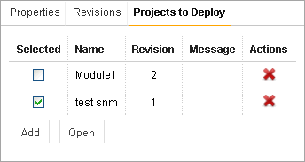
Figure 106: Deploy Configuration with projects to deploy
The Projects to Deploy tab displays existing projects to deploy of the selected deploy configuration.
- To add a new project to deploy, click Add and specify the project and revision to be included in the deploy configuration.
- Repeat this procedure to add as many projects as required.

Deploying a Deploy Configuration
To deploy a deploy configuration, save it and click Deploy.
Specified projects are deployed to Production Repository and a deployment message is displayed.
Figure 107: Deployment message
Note: Deploy Configuration cannot be deployed if any dependency projects are missed in it. Check messages on the Projects to Deploy tab.

Opening Deployed Configurations
Deploy configurations provide the means for tracking the deployment history of project revisions. OpenL Tablets WebStudio provides a functionality for quickly opening the deployed configuration revisions. This is especially useful when some time has passed since deployment and a review of files during specific deployments is desired.
To open the specific project revisions included in a deploy configuration, proceed as follows:
- In the Deploy Configuration tree, select the deploy configuration.
- In the right pane, select the Projects to Deploy tab.
- In the Selected column, select the check boxes for projects to be opened.
- Click Open.
The selected project revisions are opened in repository editor.

Redeploying Projects
OpenL Tablets WebStudio provides a function that allows a simple update and redeployment of many related deploy configurations when a particular rule project is modified. This function takes into account the revision of the opened rule project and works correctly, even with older project revisions.
To update related deploy configurations and redeploy a rule project, proceed as follows:
- In the Projects tree, select the modified rule project.
- In the right pane, click Deploy.
Note: The Deploy button is disabled if the selected project has the Local status or if it is edited.
The Auto Deploy window appears listing all existing deploy configurations whose latest revision contains a reference to the selected rule project. Deploy configurations marked for deletion are not displayed.
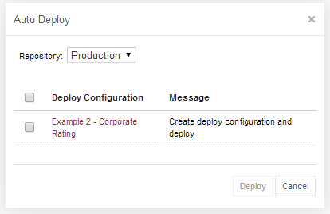
Figure 108: Deploying a project
The Message column displays the current status of displayed deploy configurations. If a particular deploy configuration cannot be deployed, the check box is gray. Possible reasons for a deploy configuration to be disabled are the following:
- The deploy configuration is saved.
- The deploy configuration is locked by another user and cannot be updated.
- The deploy configuration is up to date and references the selected revision of the rule project.
- The deploy configuration references a revision of the rule project that is higher than the one currently opened.
If the selected rule project is not referenced by any existing deploy configuration, the system offers to create a new deploy configuration containing only the rule project with an identical name.
- Select check boxes for the deploy configurations that must be updated and deployed.
- Click Deploy.
Update and deployment results are displayed in the user interface.
Figure 109: Redeployment results

Comparing Project Revisions
OpenL Tablets WebStudio provides a function for comparing files and sheets in Excel files between two project revisions.
To compare contents of the currently opened project revision with any other revision, proceed as follows:
- In the project tree, select the project.
- In the right pane, click Compare.
A window appears listing contents of the currently opened project version on the left side and contents of another project version on the right side.
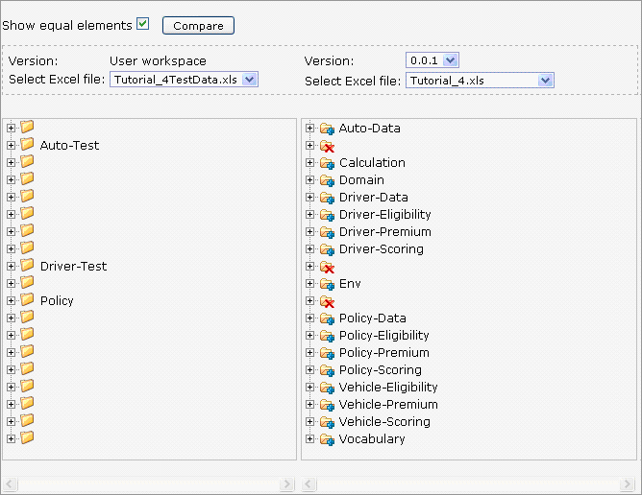
Figure 110: Comparing project versions
Green entries indicate new elements and red crosses indicate deleted or nonexistent elements.
- To compare the current project version with a different version, in the Version list box, select the version number.

Exporting a Project or a File
To export a project from Rules or Repository editor, proceed as follows:
- In the project tree, select the project.
- In the right pane, click Export.
- In the displayed window select a required project revision, click Export and a full project in the selected revision will be exported.
To export any revision of a file from Repository, proceed as follows:
- In the project tree, select the project.
- Expand the project tree and select the file to be exported.
- In the right pane, click Export file.
- In displayed window select a required file revision and click Export.
Note: If the project is in the Local status these options are not available.

Unlocking a Project
WebStudio provides a function for a user to unlock a project which is edited and, therefore, locked by another user. Be aware that after unlocking, all unsaved changes made by another user will be lost and the project will be closed.
To unlock a project, proceed as follows:
- Perform one of the following steps as required:
- In the Projects tree, select the project and, in the right pane, click Unlock.
- Click Projects in Navigator to get a list of projects, navigate to the project that needs to be removed and click the corresponding Unlock item at the right.
- In the confirmation window, click OK.
It is recommended to grant permission to the “Unlock” functionality only for administrators.

Browsing Production Repository
Production repository is a storage of project deployments where solution applications use them from. WebStudio has a possibility to connect several production repositories. For the information how to configure production repositories, refer to Repository Settings.
To browse a production repository, proceed as follows:
- Switch from Design repository to Production repositories view by clicking Production in the top of the left pane.
- In the project tree select the production repository to be browsed (repositories are marked by icon).
The list of project deployments or deployed configurations - deploy configurations which consist of rule projects and specific project revisions and deployed to the selected production repository, are displayed in the middle pane.
- If needed, expand the repository tree and browse project deployments.
WebStudio displays only the latest revisions of each deployed configuration in the production repository. By the name of the deployed configuration users can identify which specific deploy configuration revision is deployed as names of deployed configurations in production repositories have the following structure:
<deploy configuration name>#<number of a deploy configuration revision>.
Also, browsing deployed configurations in the production repository, users can see their content, namely what rules projects and their revisions are deployed.
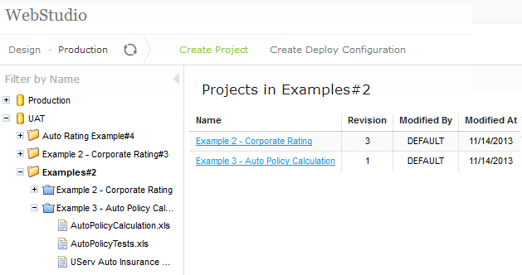
Figure 105: Production Repository with deployed projects
On the picture above there are two production repositories: Production and UAT. The latest revision of deploy configuration Examples deployed to UAT is 2 and consists of projects Example 2 - Corporate Rating of revision 3 and Example 3 - Auto Policy Calculation of revision 1.

Using Administration Tools
This section explains how to view and control OpenL Tablets WebStudio system settings and also describes the user management procedure in the system. To perform administration tasks, click the Administration item in the top line menu. By default, the System Settings tab is displayed.
The following topics are included:
- Managing System Settings
- Common Settings
- Repository Settings
- System Settings
- User Management

Managing System Settings
All System Settings are organized into the following groups: Common, Repository, and System. To open the desired group, click the corresponding icon on the left.
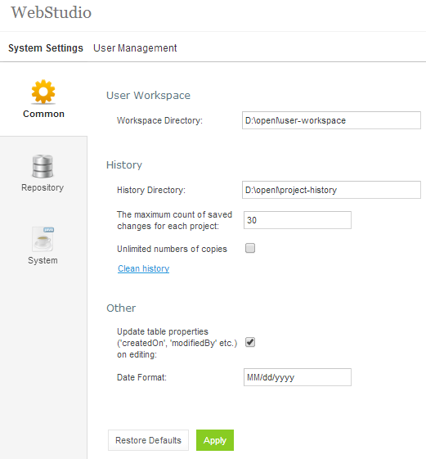
Figure 111: OpenL Tablets WebStudio Administration
Normally, the default settings are recommended but users with appropriate permissions can change them as needed. After making changes, click Apply and refresh the page. To restore the original settings, click the Restore Defaults button.
The following topics are included in this section:
- Common Settings
- Repository Settings
- System Settings

Common Settings
The Common section defines general WebStudio settings described below:
- User Workspace
- History
- Other

User Workspace
Defines Workspaces Directory where the user’s projects must be located.

History
History Directory – Shows where user’s projects history files are saved. These files are used to track, compare and revert changes made in projects.
Unlimited numbers of copies – If unchecked makes it possible to define the number of history files to be saved for a project.
To specify a number of history files, proceed as follows:
- Clean the Unlimited numbers of copies checkbox.
Note: This checkbox is selected by default.
- In the The maximum count of saved changes for each project field enter the desired number.
Note: By default, this field is set 30.
- Click Apply to save changes.
- Click OK in the confirmation dialog.
To clean all the history files for the project, perform the following steps:
- Click the Clean history link.
- In the Clean projects history form, select checkbox for a particular project, or select the “Name” to clear history for all projects.
- Click Clean to complete.

Other
Update table properties… - Indicates whether table properties controlled by the system must be updated and can be viewed in the WebStudio UI. If the option is unchecked, the information about who and when created or modified tables such as Created By/On, Modified By/On is not added to the tables properties.
Date Format – Enables changing the date format in the WebStudio Interface.

Repository Settings
The Repository section contains connection settings of Design and Production repositories:
- connection name displayed as a repository name in repository editor
- connection type and repository directory path, which define a repository to be used as a data source:
Connection types for setting up design and production repositories
Type | Description
Local | The Repository is located on the local machine as a folder. This folder must be specified in the Repository Directory field.
Remote - RMI | The Repository is located on a remote server and can be accessed by the RMI protocol. The Repository URL field displays URL for remote access to the repository.
Remote - WebDav | The Repository is located on a remote server and can be accessed via WebDav protocol. The Repository URL field displays URL for remote access to the repository.
For more information on repository settings, refer to [OpenL Tablets Web Services Usage and Customizations Guide], Data Source Configuration section.
- login and password if the repository is remote and secured.
To set up a secure connection, select the Secure connection checkbox and fill in the login and password fields.
For more information on repository security, refer in the [OpenL Tablets Installation Guide], Configuring Private Key for Repository Security section.
The settings can be changed by editing on the tab or deleted by clicking the red cross .
Connection to a local production repository is configured by default. To connect more Production repositories, click the Connect To Production Repository button, enter the repository parameters as needed and click Connect.
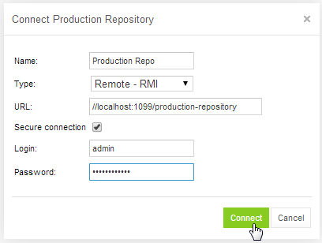
Figure 112: Connecting Production Repository
The Repository tab provides an option to create a local production repository: click the Create Production Repository button, in the form enter new repository parameters and click Create.
Do not forget to click Apply to save changes and refresh the page.

System Settings
The System tab provides the following options:
- Core
- Project
- Testing

Core
Custom Spreadsheet Type – indicates whether the Custom Spreadsheet Result type feature is turned on or off. By default the feature is turned on. To make the feature inactive, deselect the Custom Spreadsheet Type checkbox.
Rules Dispatching Mode – indicates what rule tables dispatching mode is set:
- Java – is set by default
- Decision Table

Project
The maximum number of cached projects – defines the maximum number of compiled projects that can be cached at the same time during WebStudio run. Five projects are set by default. Value 0 means that the number of projects is unlimited.
The time to store a project in cache (in seconds) – determines how many seconds a compiled project can be stored in cache memory. Default setting is 300. Value 0 means that the time to store is unlimited.

Testing
Run test cases of the test in parallel - if checked, makes it possible to reduce the time spent on executing test cases of a test table by configuring the number of parallel threads in the field below. User can turn off this setting, then all test cases will be executed one by one.
Thread number for tests – by default four threads are set. It means that after clicking Run test table, or run all tests, button – up to four test cases will be in progress at the same time. After they are calculated, next four test cases will be performed.

User Management
This section describes how to control user access in the OpenL Tablets WebStudio application based on users and user groups. All privileges in the system are assigned at a group level and will be granted to a particular user after he or she is included in a particular group.
Users and groups are managed from the User Management tab which, in turn, is divided into Users and Groups & Privileges tabs. Only members of the Administrators group have rights to manage users and groups in the WebStudio.
The following topics are included:
- Managing Groups
- Managing Users

Managing Groups
Section explains how to create, modify, and delete a user group with a certain set of privileges. The Administrators group cannot be deleted from the system.
The following topics are included in this section:
- Viewing a List of Groups
- Adding a Group
- Editing a Group
- Deleting a Group

Viewing a List of Groups
To view a list of groups, proceed as follows:
- From the Administration tab, click User Management on the top-left of the screen.
- Click Groups & Privileges at the left.
The system displays a list of groups similar to the following one:
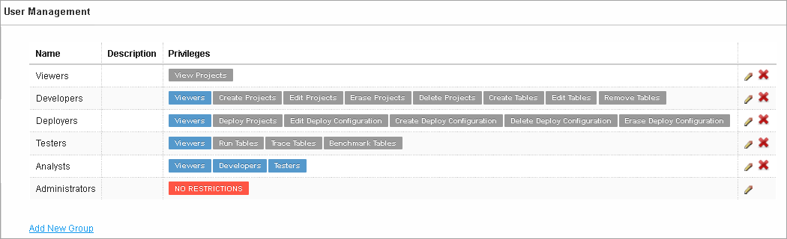
Figure 113: User groups in the Groups & Privileges tab
- To create a new group, proceed as described in Adding a Group.
- To edit a group, proceed as described in Editing a Group.
- To delete an existing group, proceed as described in Deleting a Group.

Adding a Group
To add a new group, proceed as follows:
- Click the Add New Group link.
The Add New Group form appears.
- Enter the group name in the Name field.
- Enter any useful information in the Description text box.
This step is optional.
- In the Privilege area select the privileges as needed.
To assign a set of privileges for the group, click the name of the group above the list of privileges: Developers, Deployers, etc. The Viewers group is selected for a new user group by default.
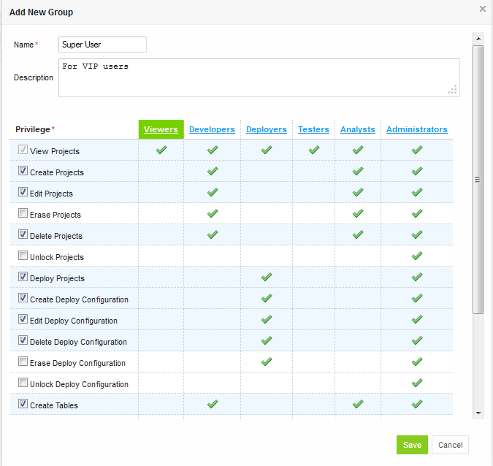
Figure 114: Add a new user group with required set of privileges
- Click Save.

Editing a Group
To modify a user group, proceed as follows:
- In the list of groups, locate the group that needs to be changed and click the Edit icon .
- In the Edit Group form, change the group name, add or modify its description and change privileges as needed.
- Click Save to complete.

Deleting a Group
To delete a user group, proceed as follows:
- Locate the group to be deleted and click the red cross at the right: .
- Click OK in the confirmation dialog.

Managing Users
Users get access to WebStudio functions by including them in particular groups.
By default, there are the following users in OpenL Tablets WebStudio:
OpenL Tablets WebStudio users
User name | User password | Groups
user | user | Viewers
u0 | u0 | Testers
u1 | u1 | Developers, Analysts
u2 | u2 | Viewers
u3 | u3 | Viewers
u4 | u4 | Deployers
a1 | a1 | Administrators
On the first start of the WebStudio, users re provided with a1/a1 login/password pair that gives users Administrator’s permissions. Users can then set up their own users in the WebStudio as needed. For information about the permissions of the groups, refer to Managing Groups.
The following topics are included in this section:
- Viewing a List of Users
- Creating a User
- Editing a User
- Deleting a User

Viewing a List of Users
To view a list of users, proceed as follows:
- From the Administration tab, click User Management at the top-left of the screen.
- Click Users at the left.
The system displays a list of WebStudio users.
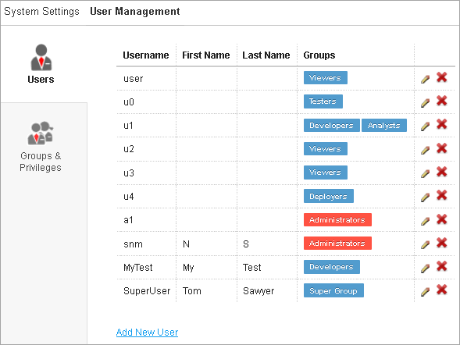
Figure 115: List of OpenL Tablets WebStudio Users
- In the Users tab perform either of the following:
- To create a new user, proceed as described in Creating a User.
- To edit a user, proceed as described in Editing a User.
- To delete a user from the system, proceed as described in Deleting a User.

Creating a User
While creating a new user, make sure to include the user in at least one group. Proceed as follows:
To create a new user, proceed as follows:
- Click the Add New User link.
The system displays the Add New User form.
INCLUDEPICTURE "../../../../../Users/epoyasok/AppData/Local/Temp/SNAGHTML10f25008.PNG" \* MERGEFORMAT 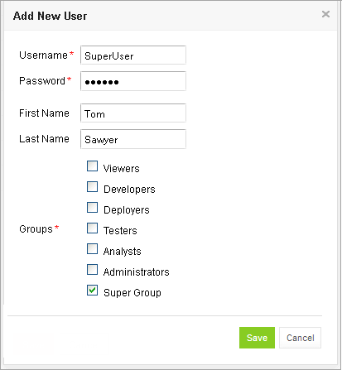
Figure 116: Creating a new user
- Specify the user’s login in the Username field and enter the password in the Password field.
- Enter the user’s first and last name.
This step is optional.
- Select one or more groups to assign the user to.
- Click Save to complete.
The system displays the new user in the Users list.

Editing a User
To edit a user, proceed as follows:
- In the Users list, locate the user that needs to be modified and click the Edit icon: .
- In the Edit User form, change the user First Name, Last Name, and select or deselect the groups to include the user in.
Users with the administrator privilege can also reset passwords of other users.
- Click Save to save the changes.

Deleting a User
To delete a user, proceed as follows:
Warning: There must be at least one Administrator as a member of the Administrators group in the WebStudio, i.e. the only WebStudio Administrator cannot be deleted.
- In the Users list, locate the user for deletion and click the Delete icon: .
- Click OK in the confirmation dialog.

Index

A
advanced functionality, 51
B
benchmarking, 69
D
deploy configuration
creating, 89
defining projects to deploy, 89
deploying, 90
deployed project
opening, 90
Design Repository
browsing, 72
F
file
deleting, 86
uploading, 85
folder
creating, 84
deleting, 86
G
guide
audience, 6
related information, 6
typographic conventions, 6
M
module
opening, 22
O
OpenL Tablets WebStudio
logging in, 11
OpenL Tablets WebStudio
components, 9
definition, 8
security, 10
working with projects, 8
OpenL Tablets WebStudio, 8
P
project
closing, 80
compare versions, 27
copying, 87
creating, 74, 77
deleting, 88
deploying, 88
deployment, 89
editing, 24, 80
erasing, 88
exporting, 85, 92
managing, 23
modifying, 81
modifying contents, 84
modifying properties, 81
opening, 79
redeploying, 90
removing, 87
saving, 24, 80
unlocking, 93
project dependency
defining, 30
project tree
filtering, 73
project versions
comparing, 91
R
repository editor, 19
using, 72
rules editor, 14
managing projects, 23
opening a module, 22
overview, 14
using, 21
view modes, 16
S
search
advanced, 41
performing, 40
simple, 40
security, 10
T
tables
modifying, 32
viewing, 31
tracing, 66
U
unit tests, 58
V
view modes, 16

